**Configure and Connect a MySQL Database Instance with a Web Server and Set up the Monitoring of the Solution**

**Step 1: Create the Database in the AWS Console**

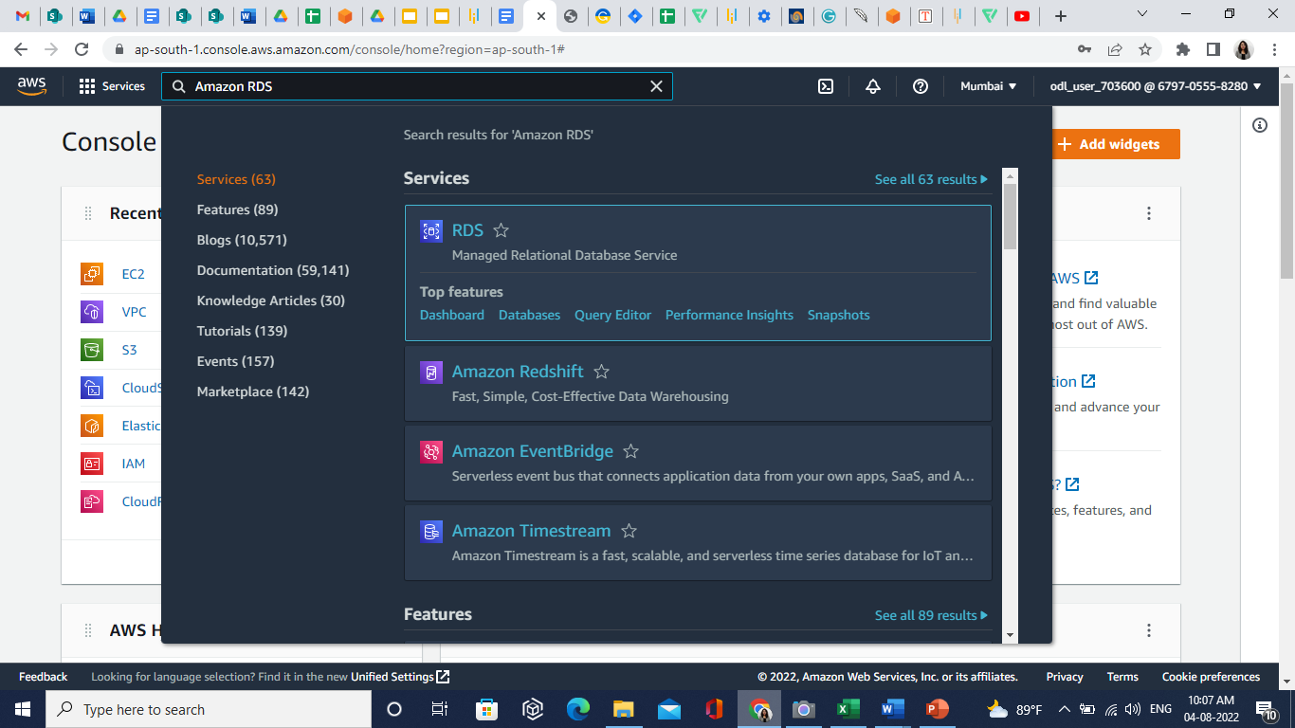

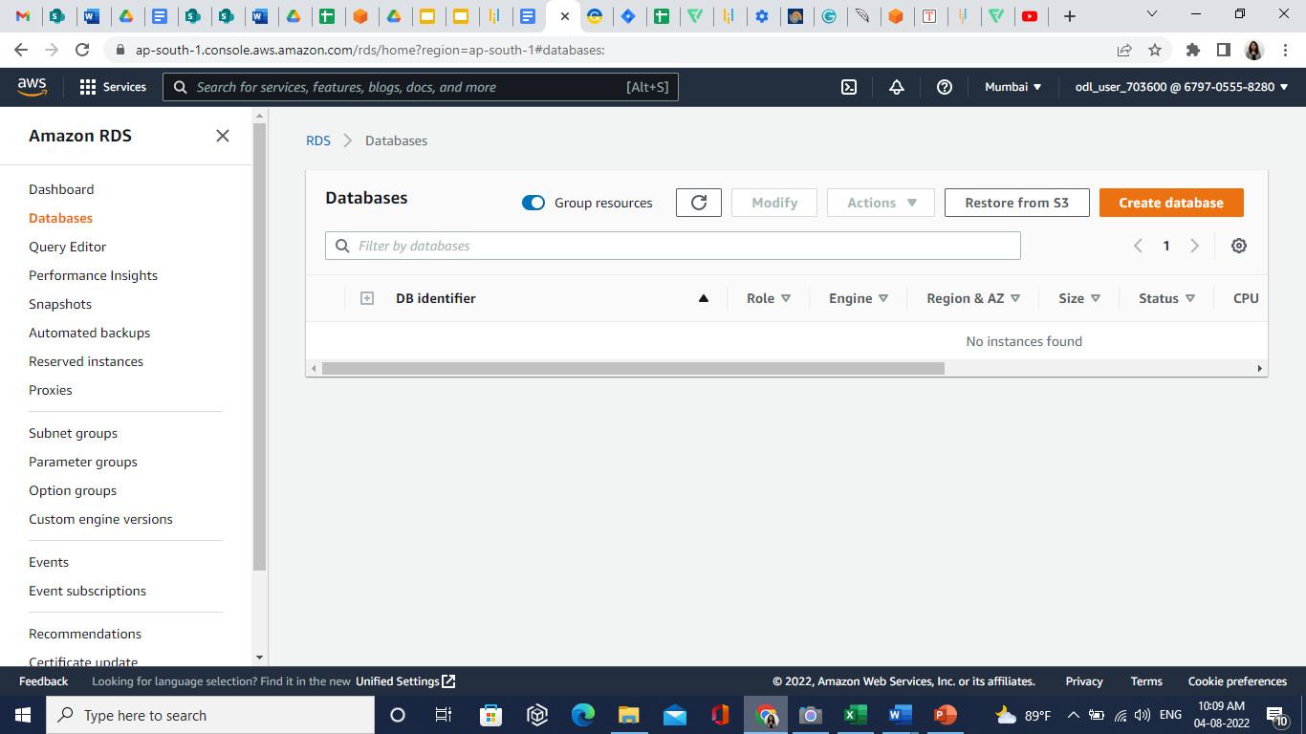

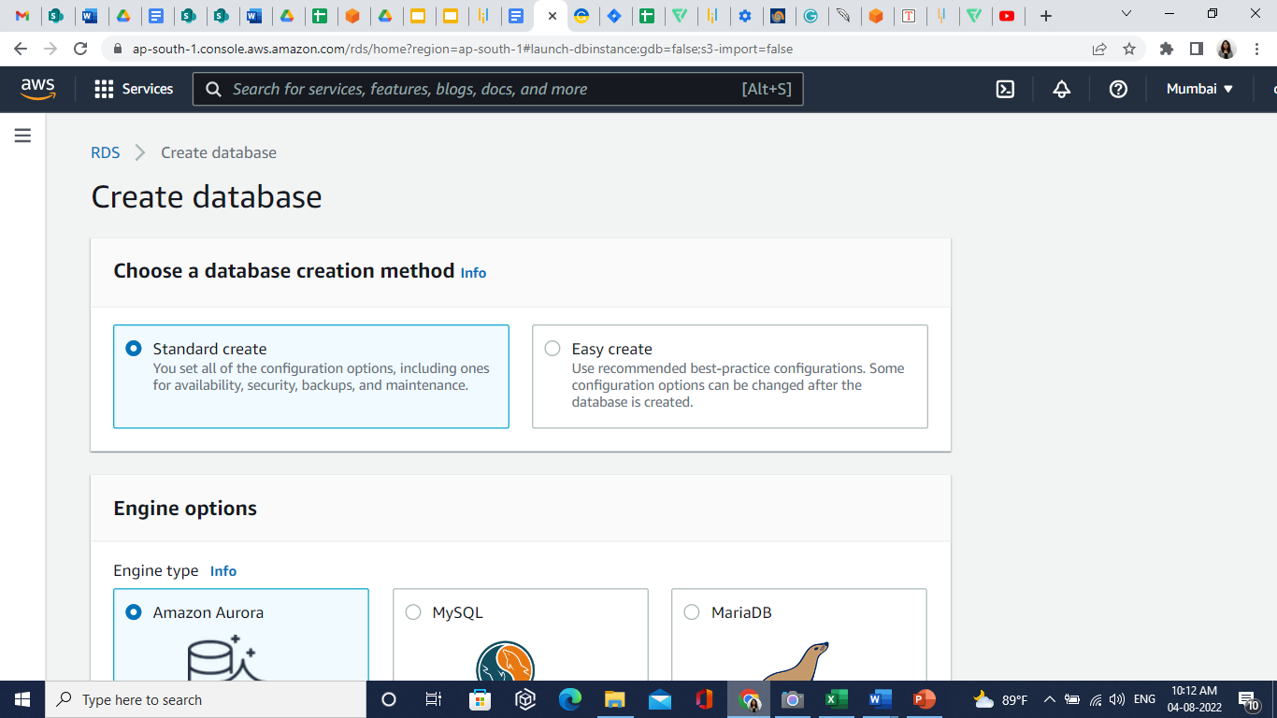

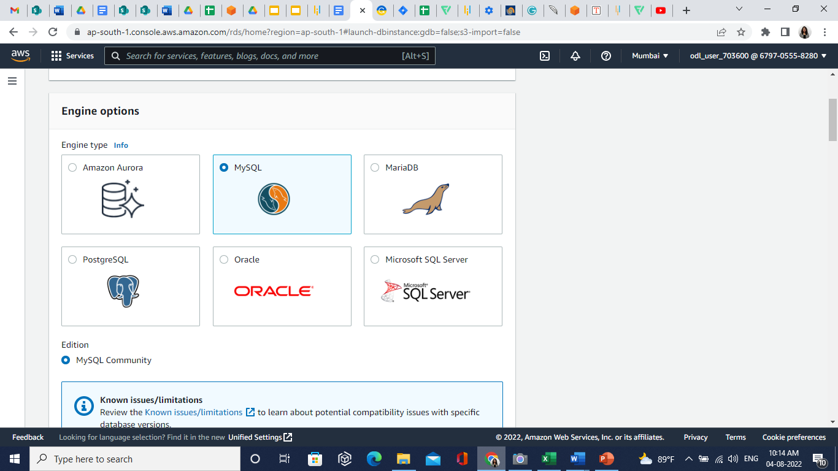

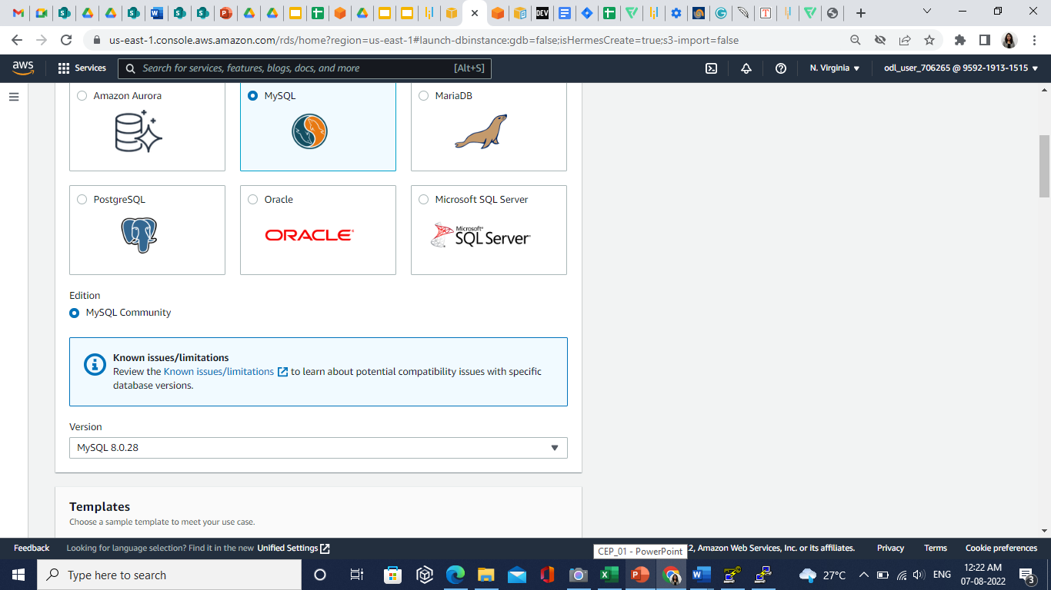

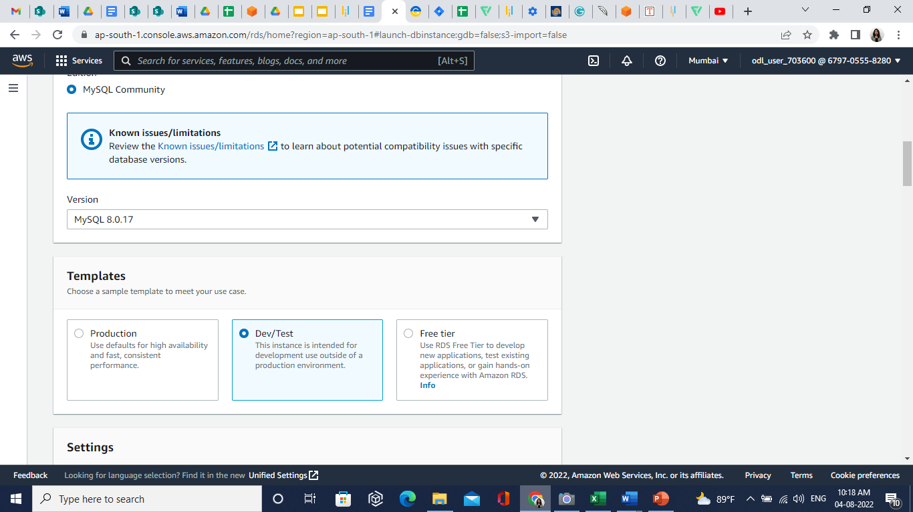

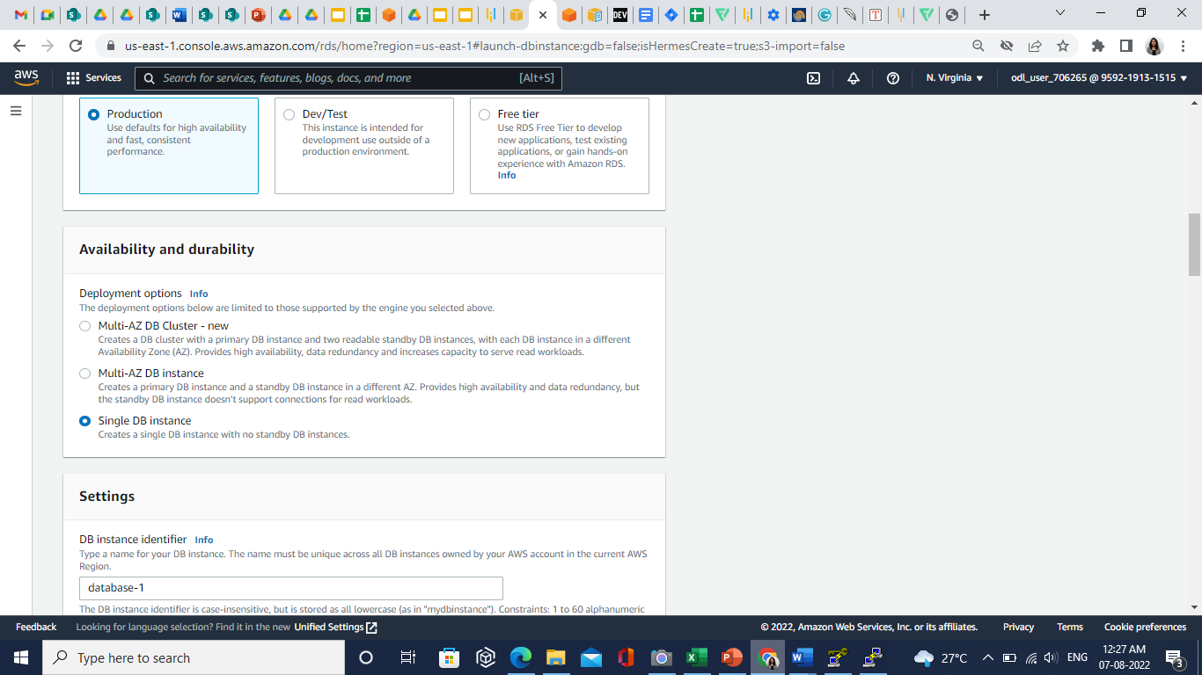

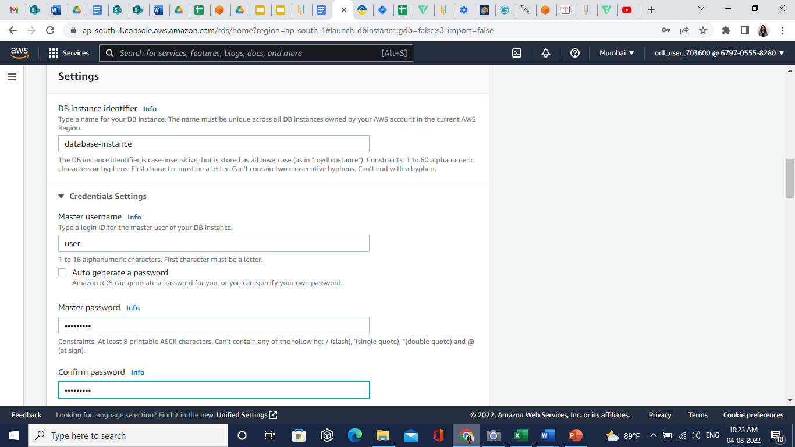

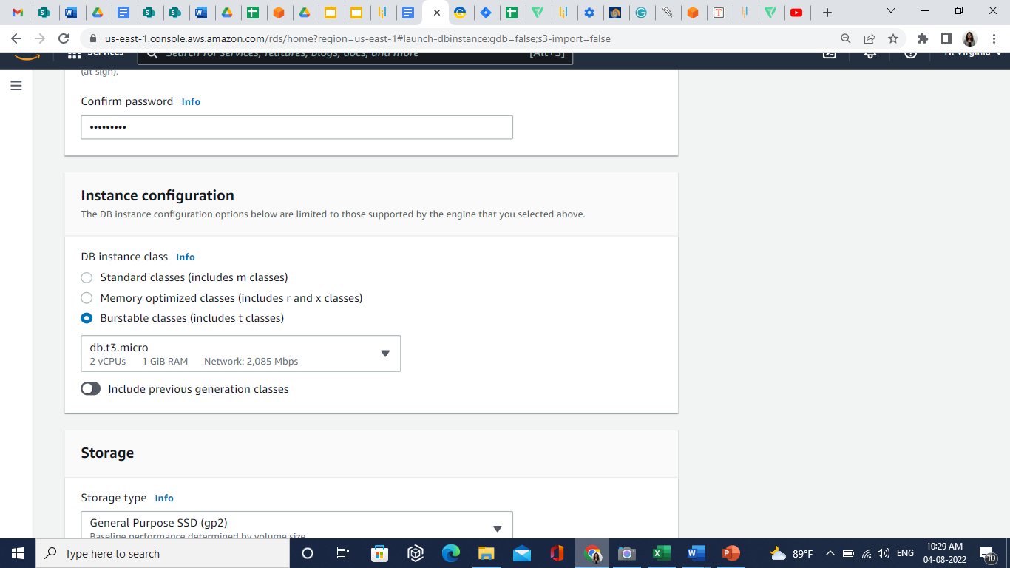

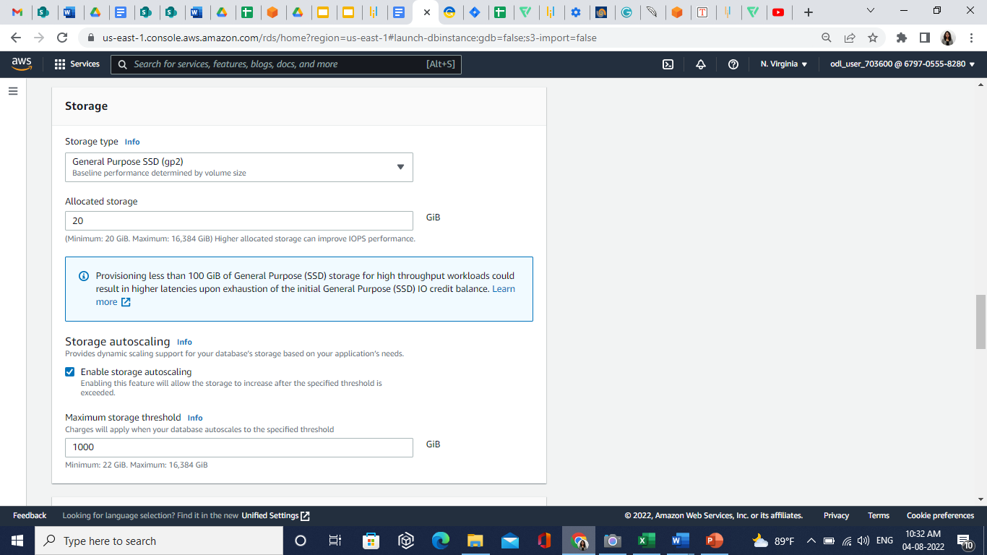

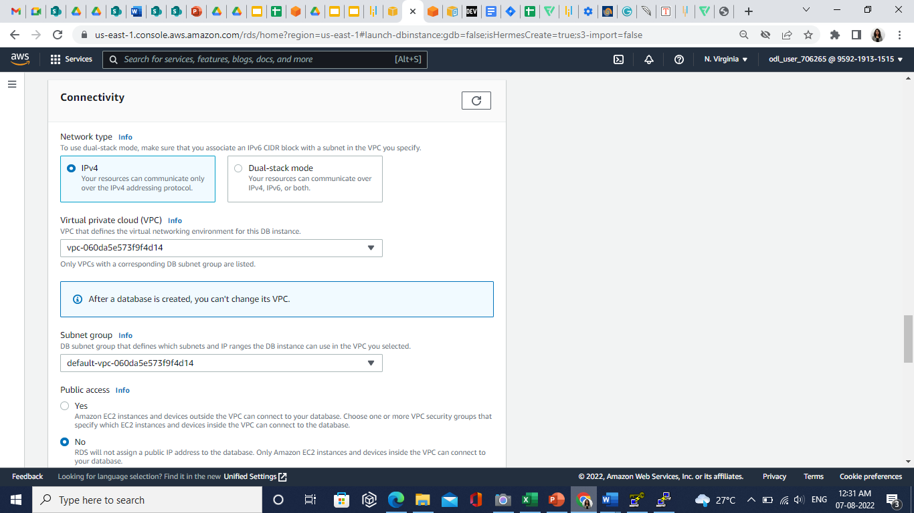

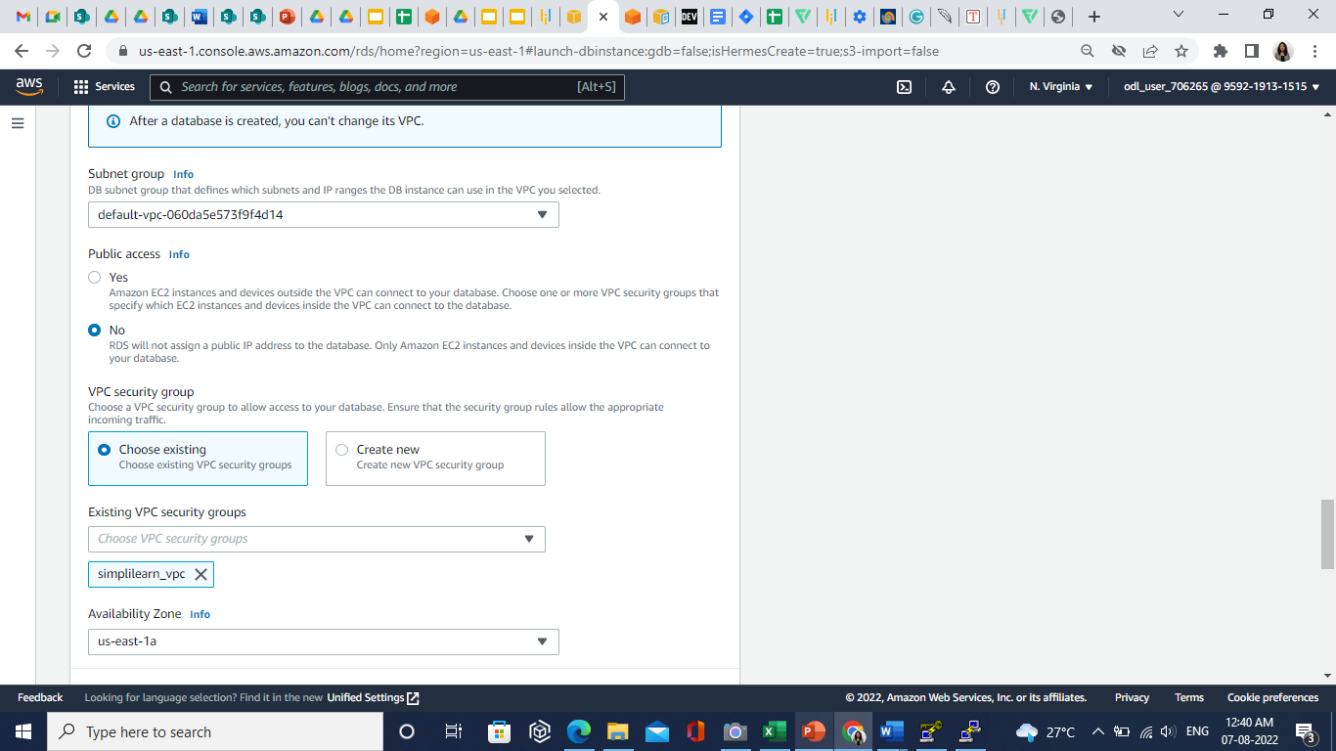

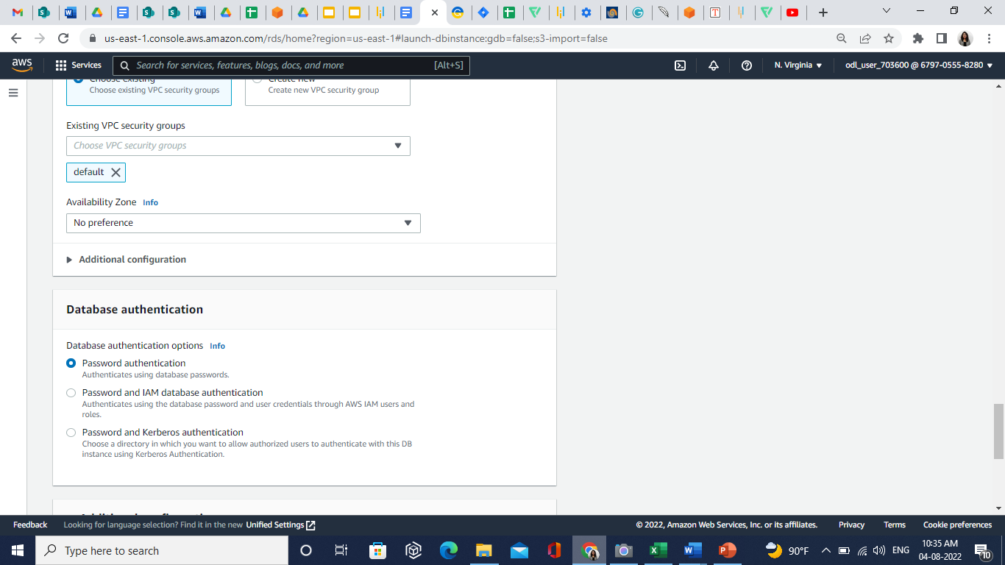

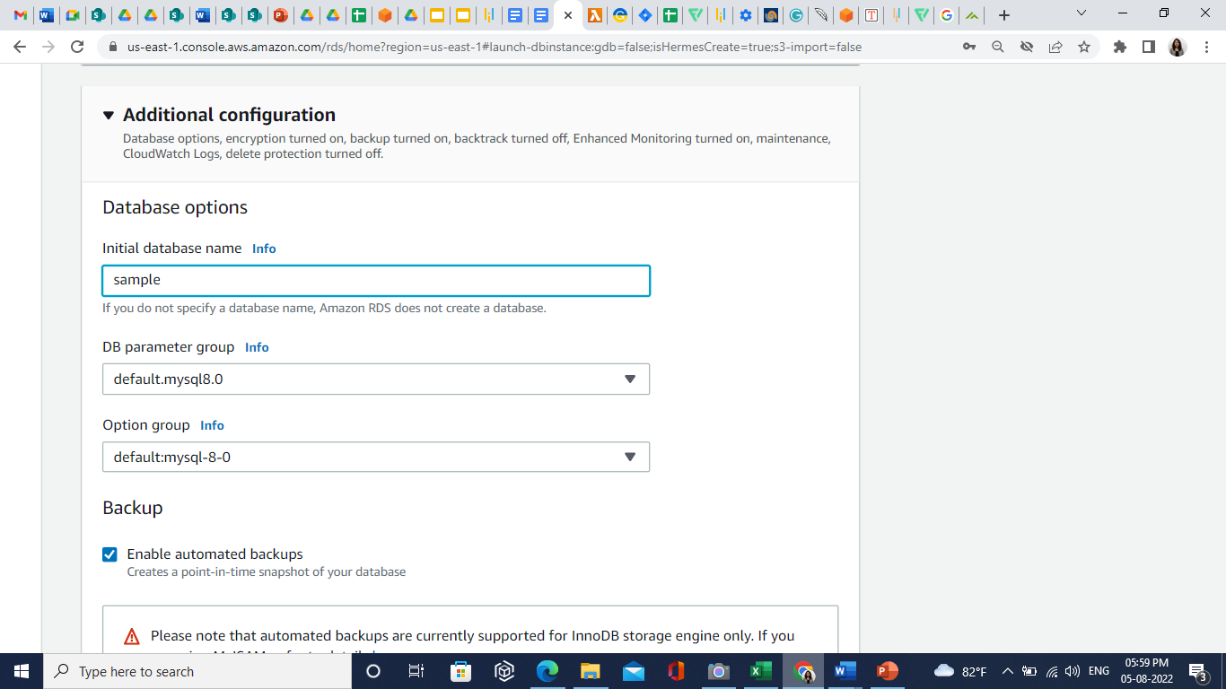

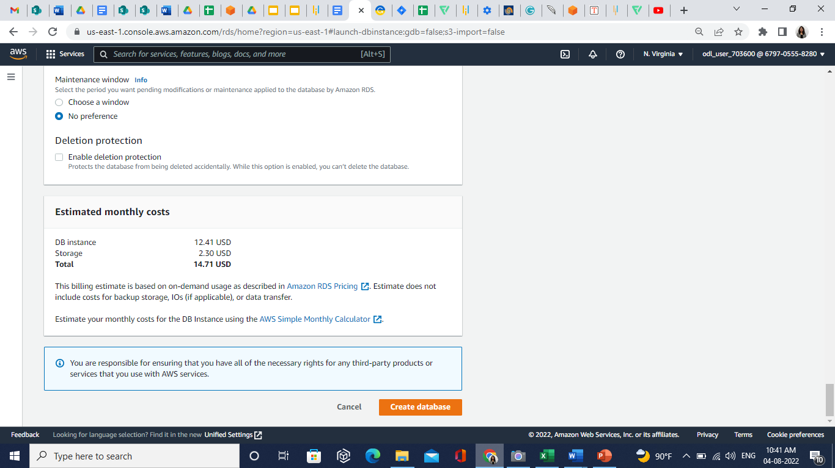

**Step 2: Launch an EC2 Instance**

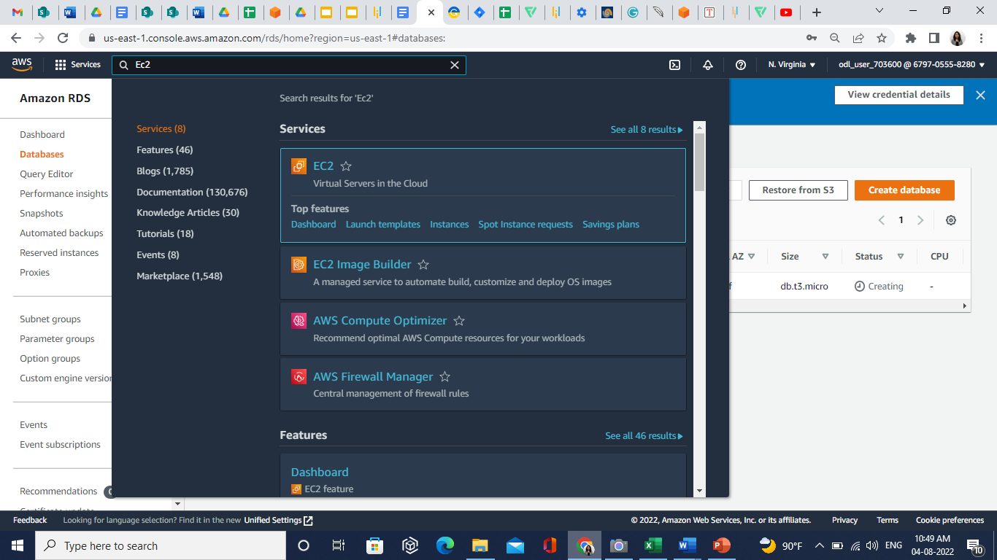

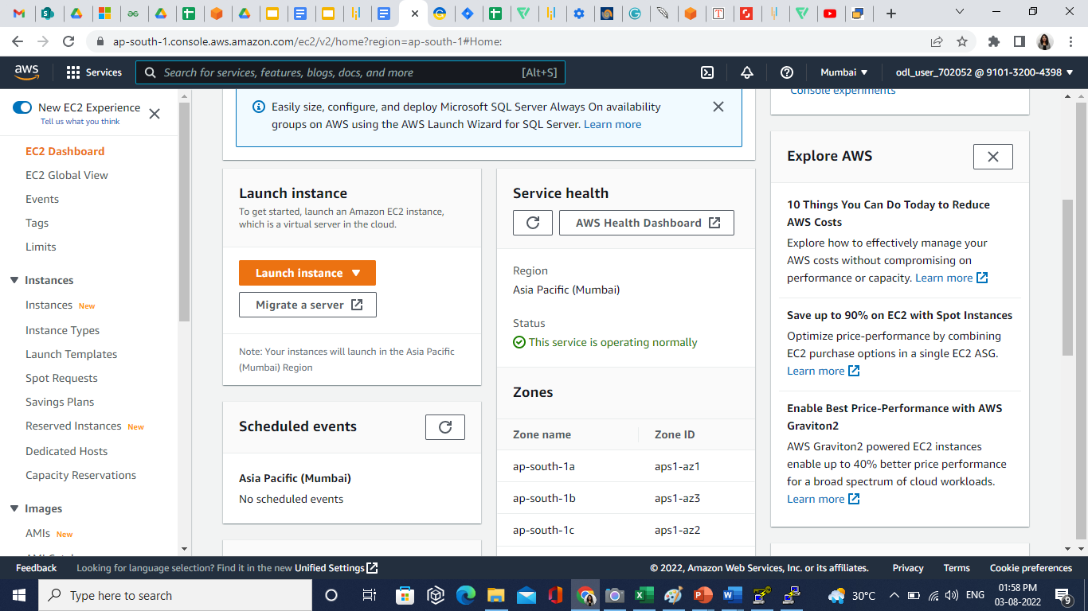

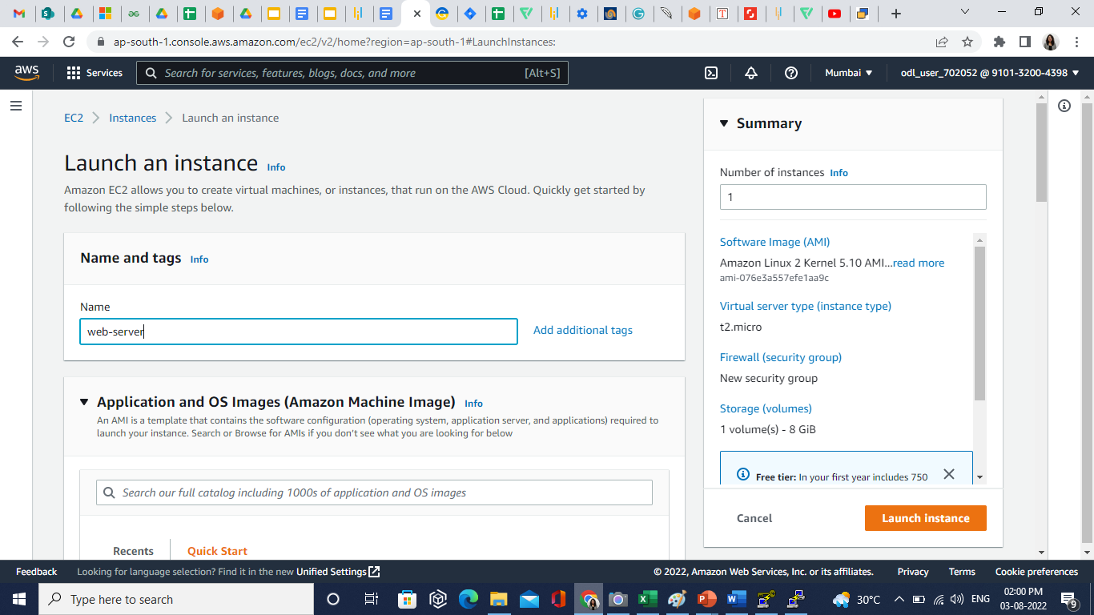

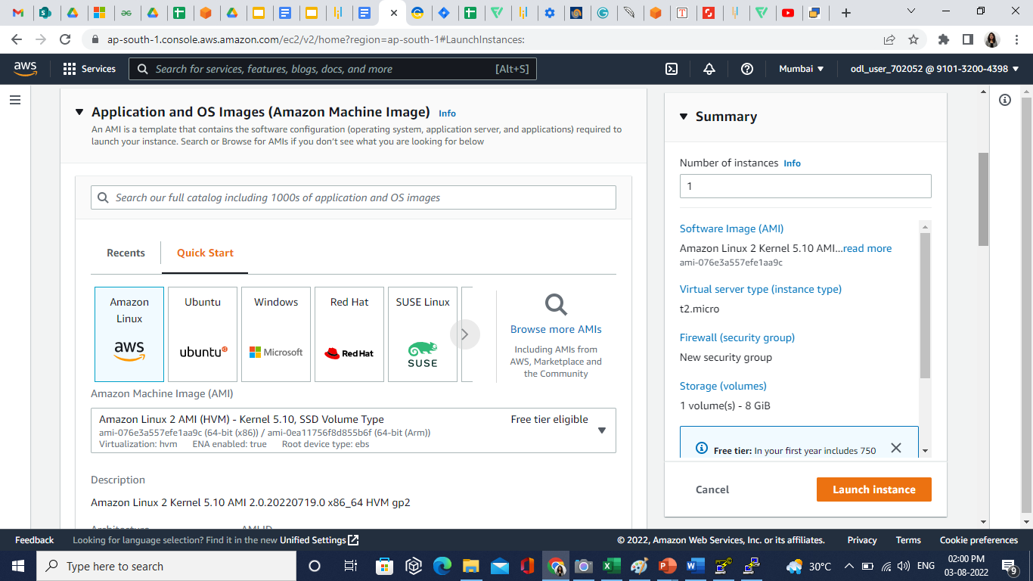

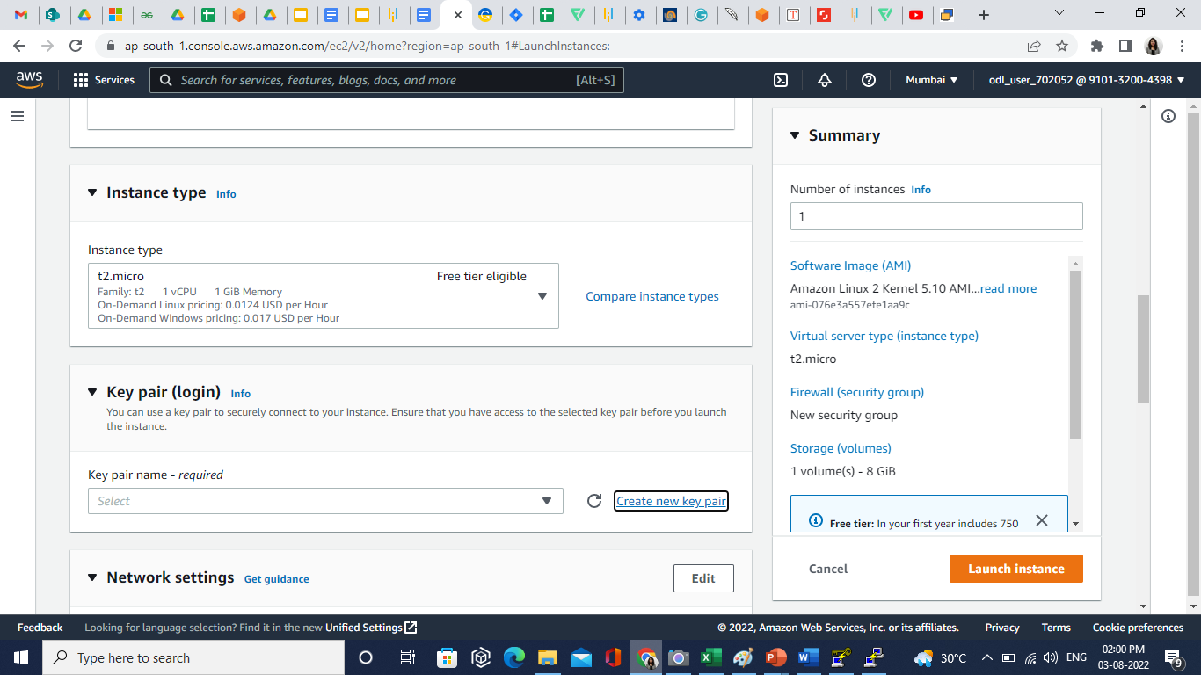

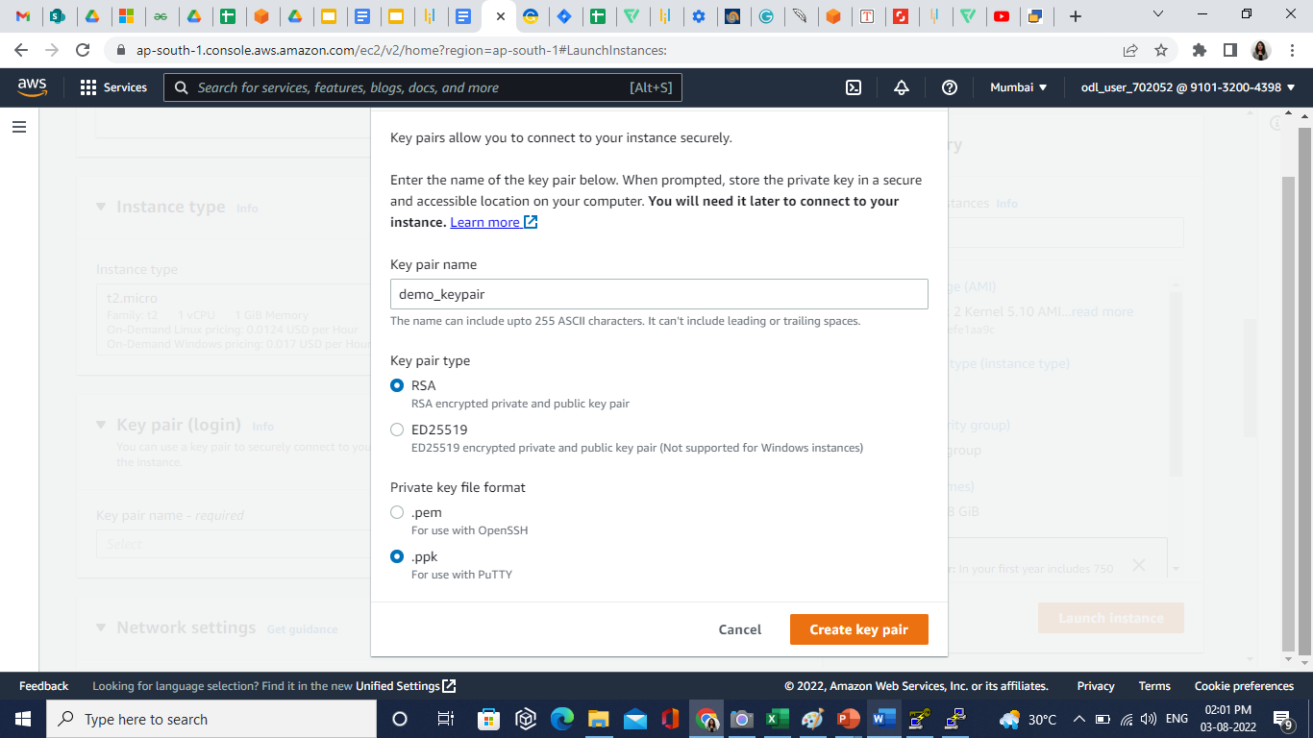

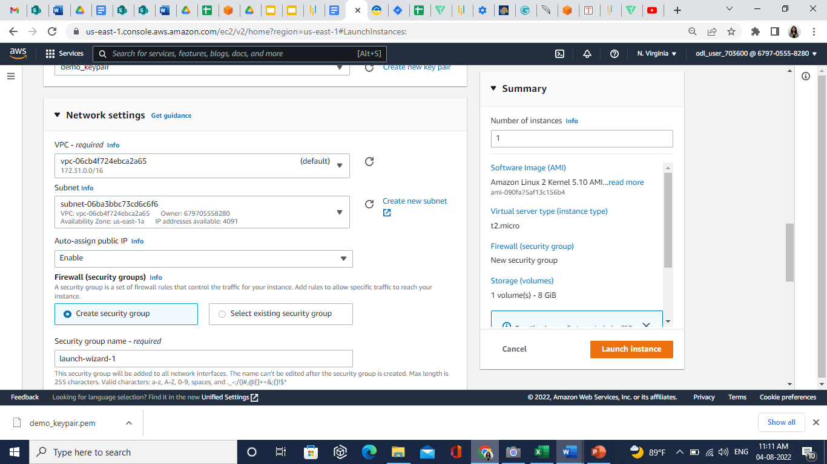

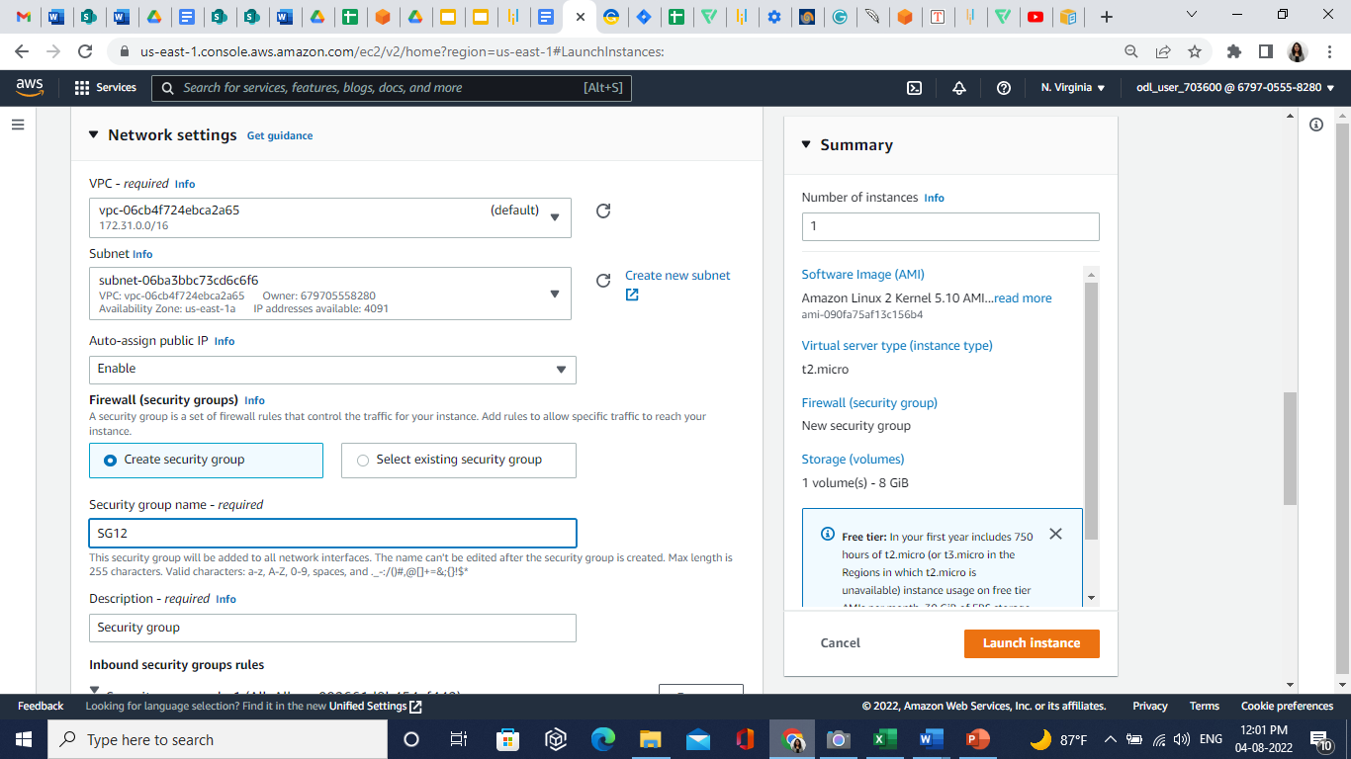

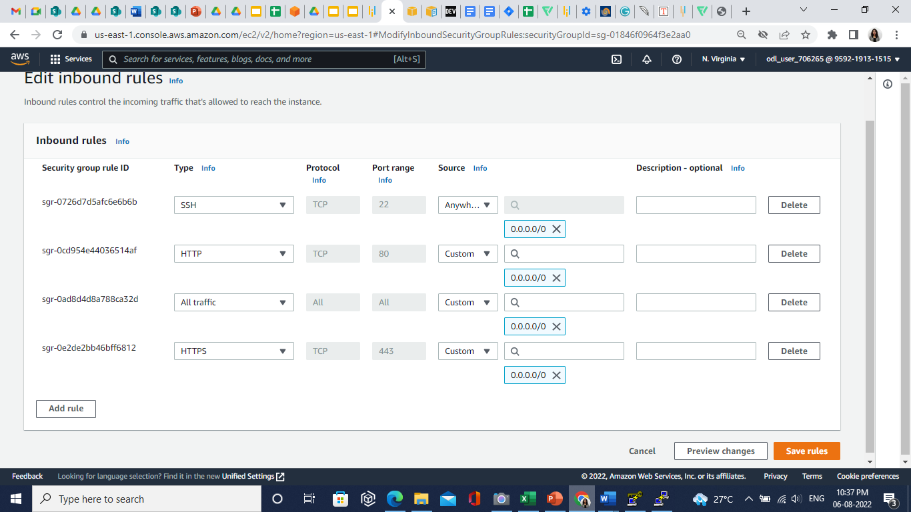

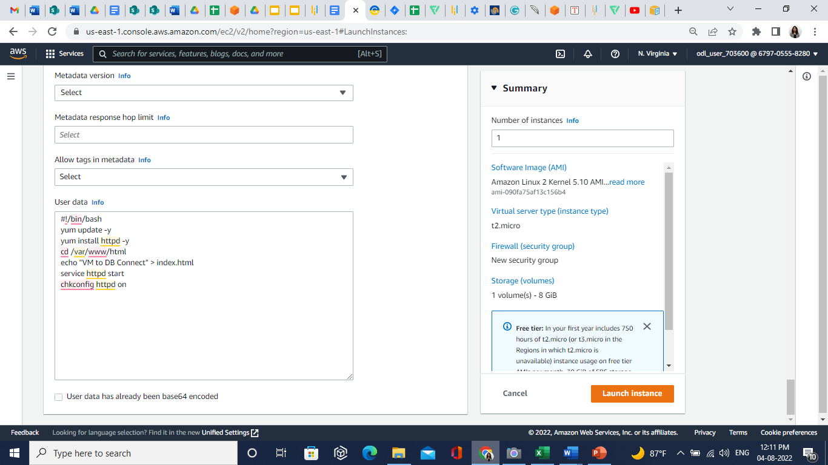

**Step 3: Convert a Private Key to PuTTY using PuTTYgen**

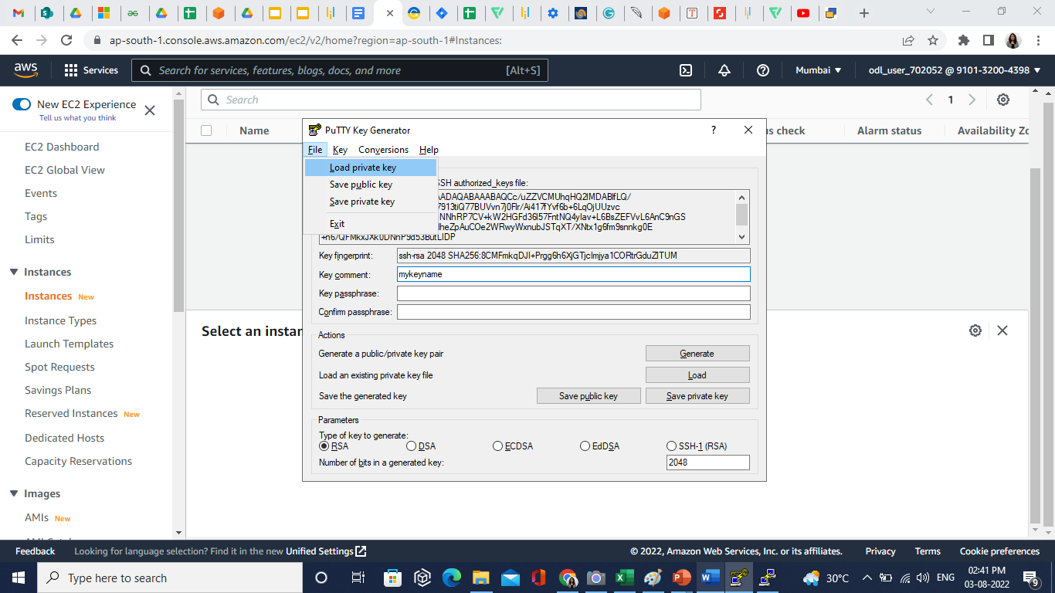

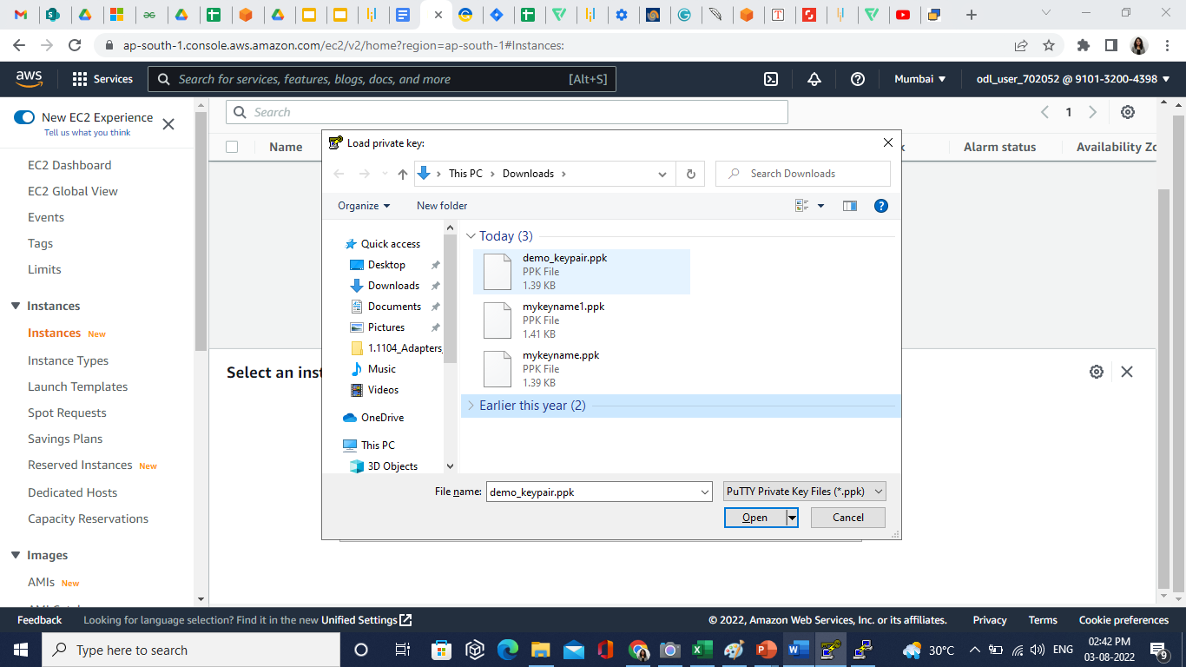

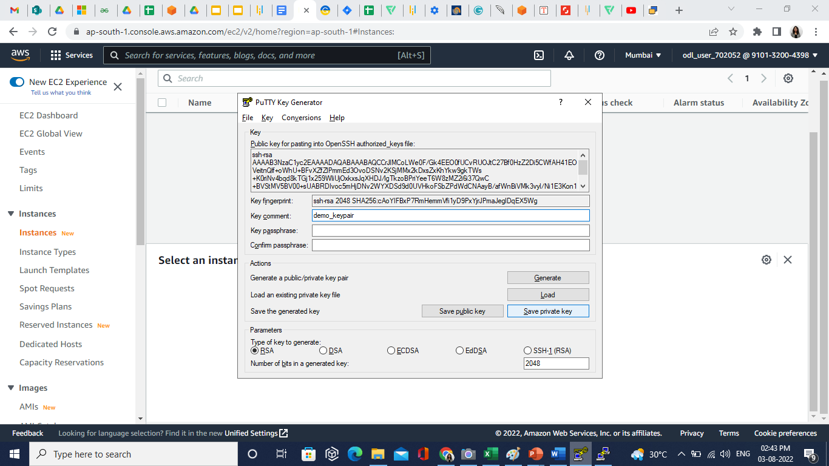

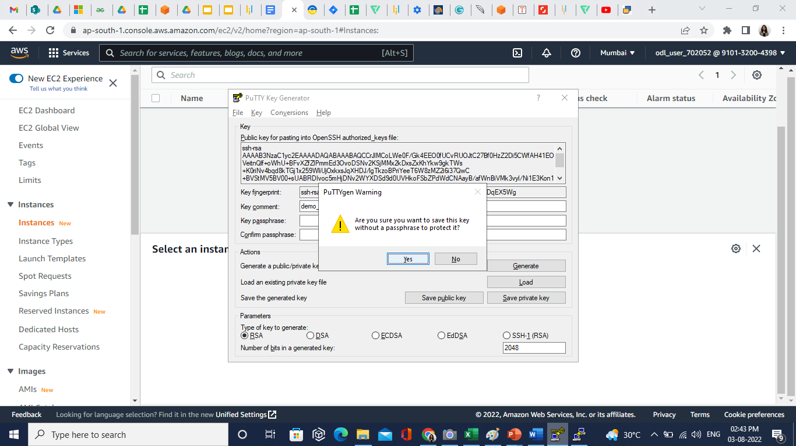

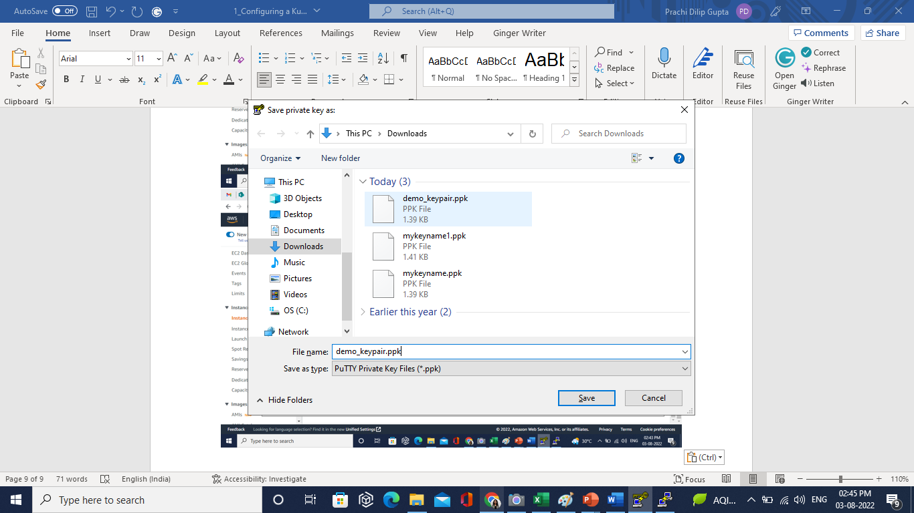

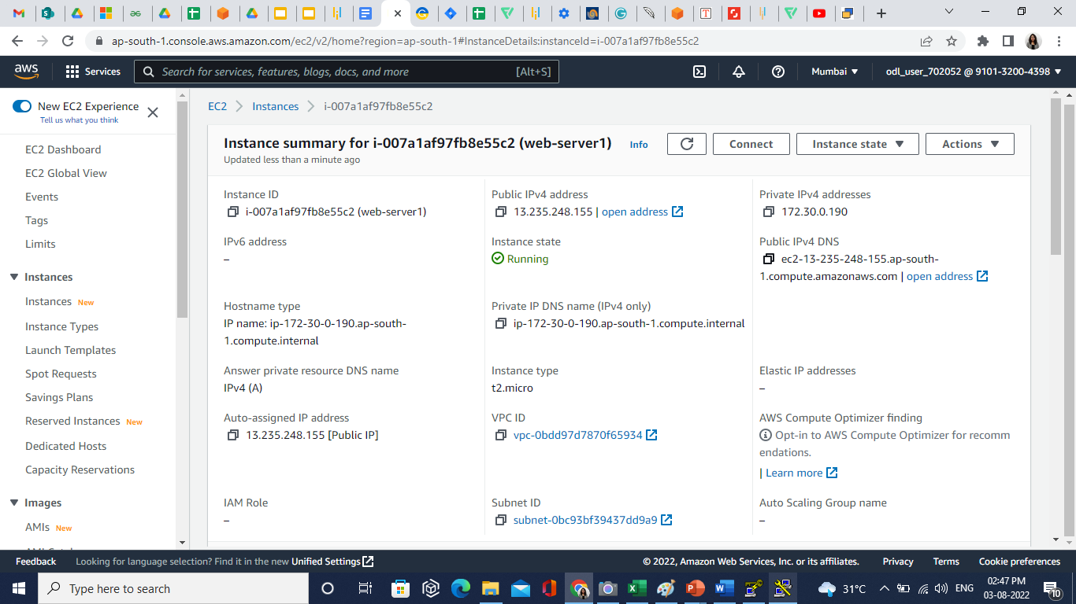

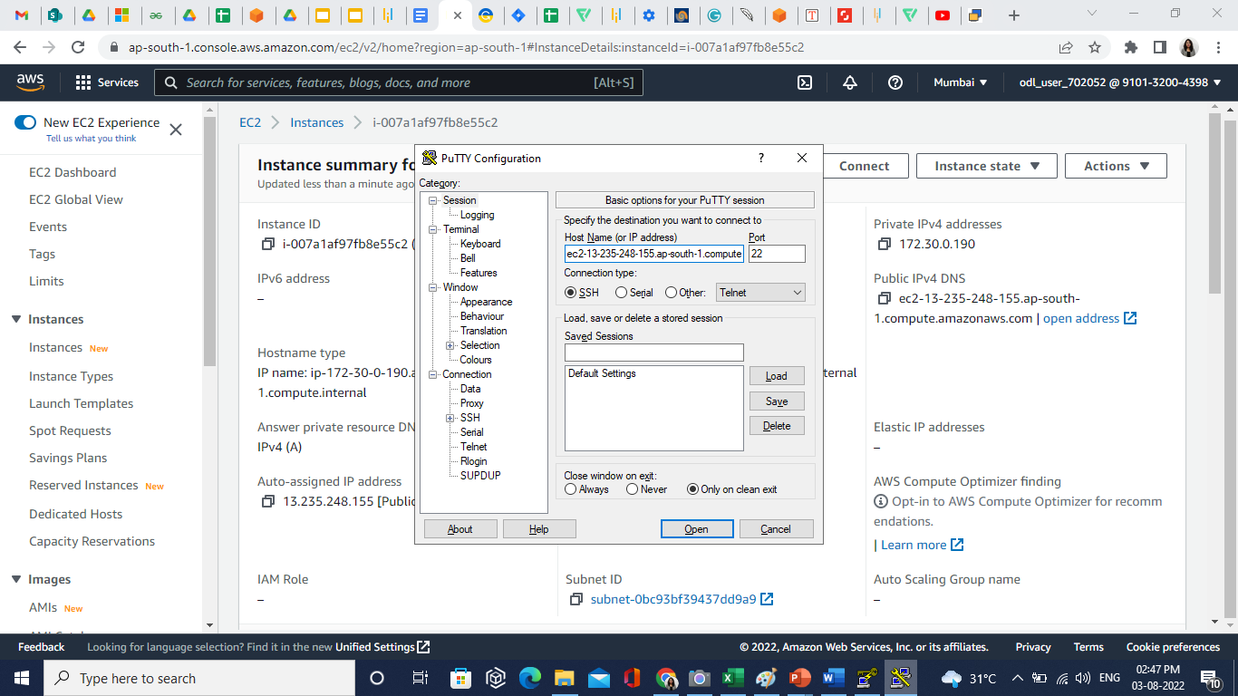

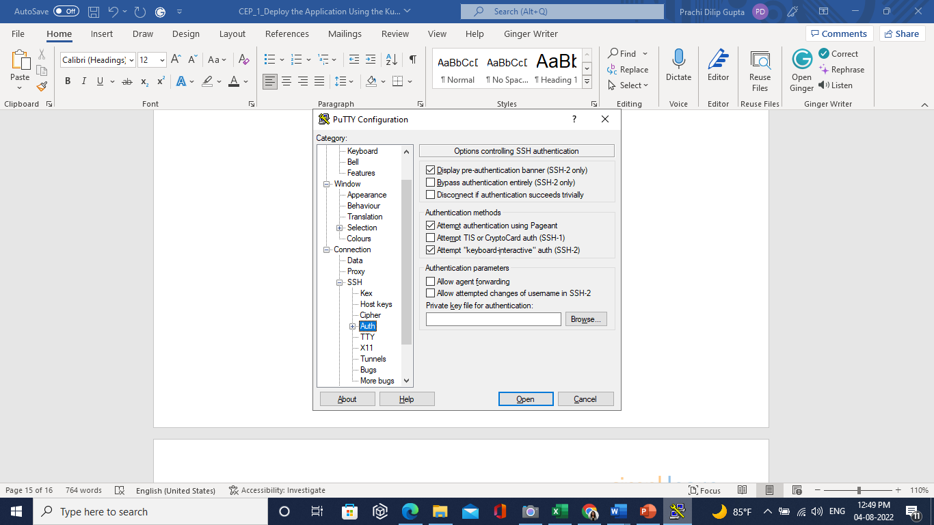

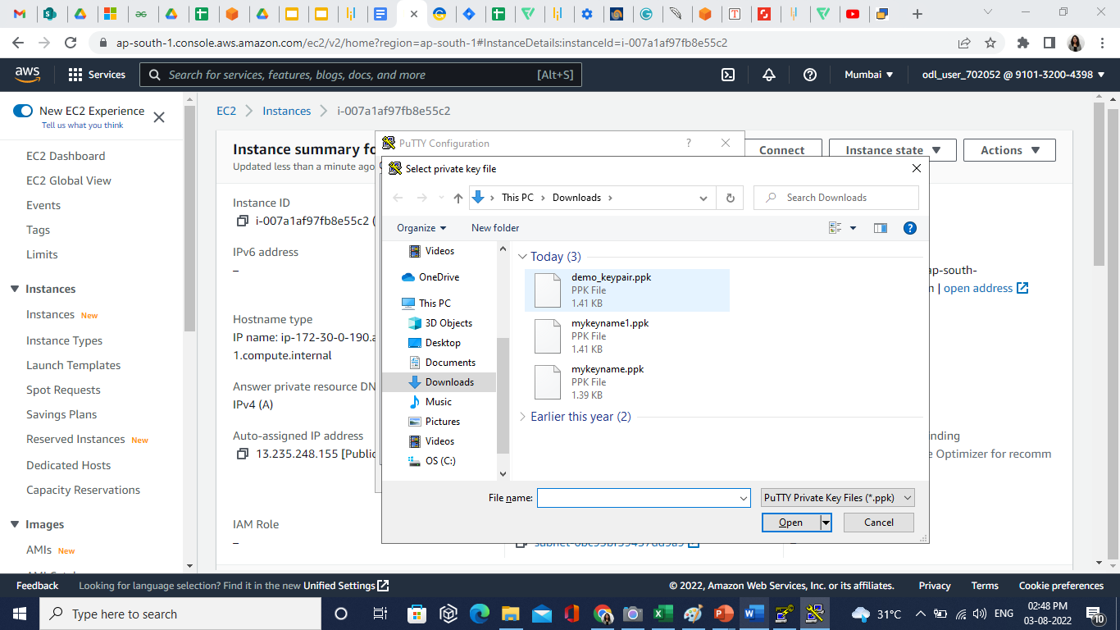

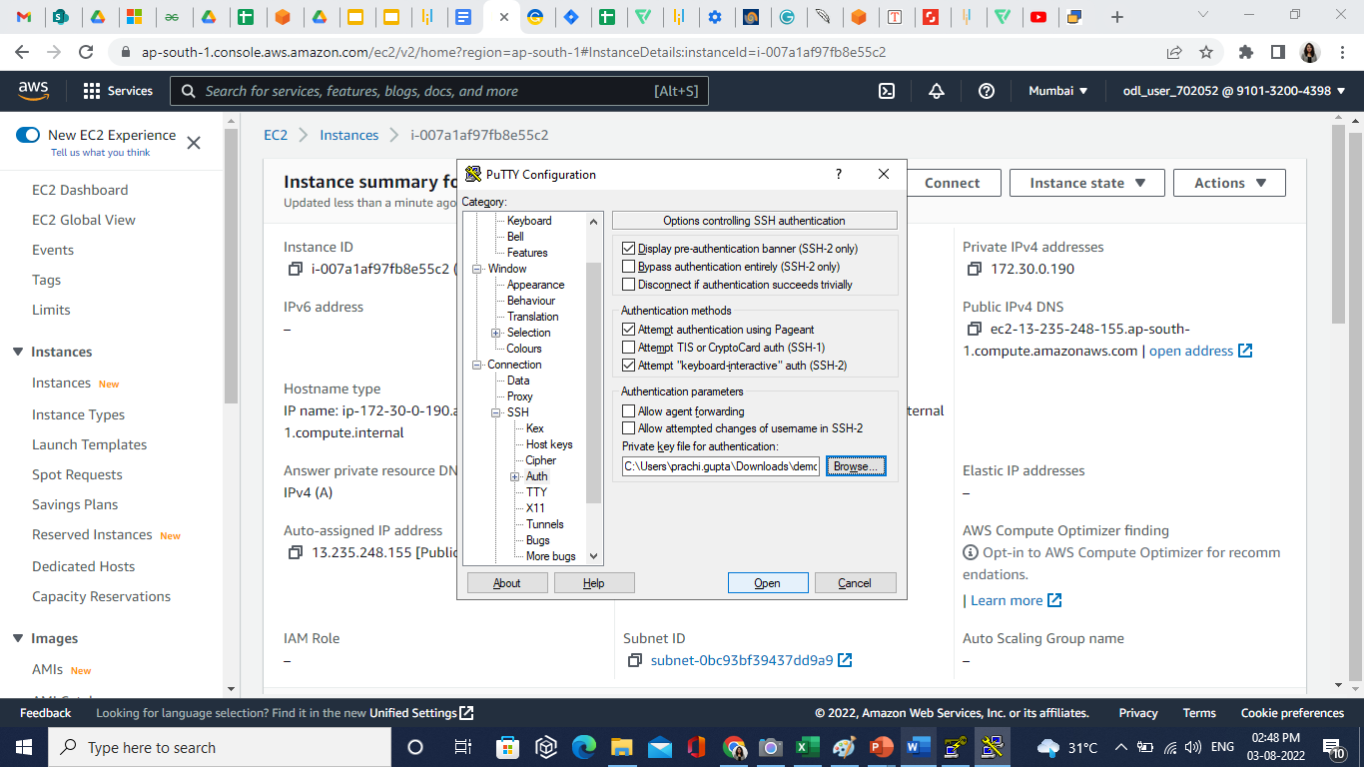

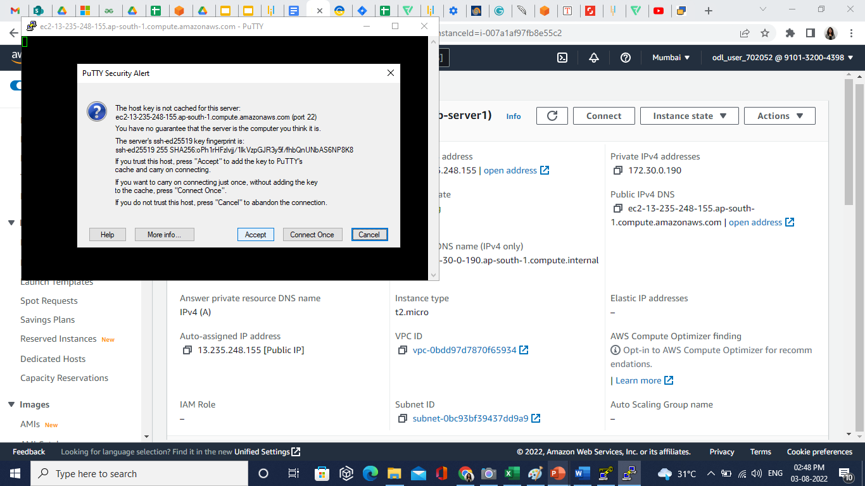

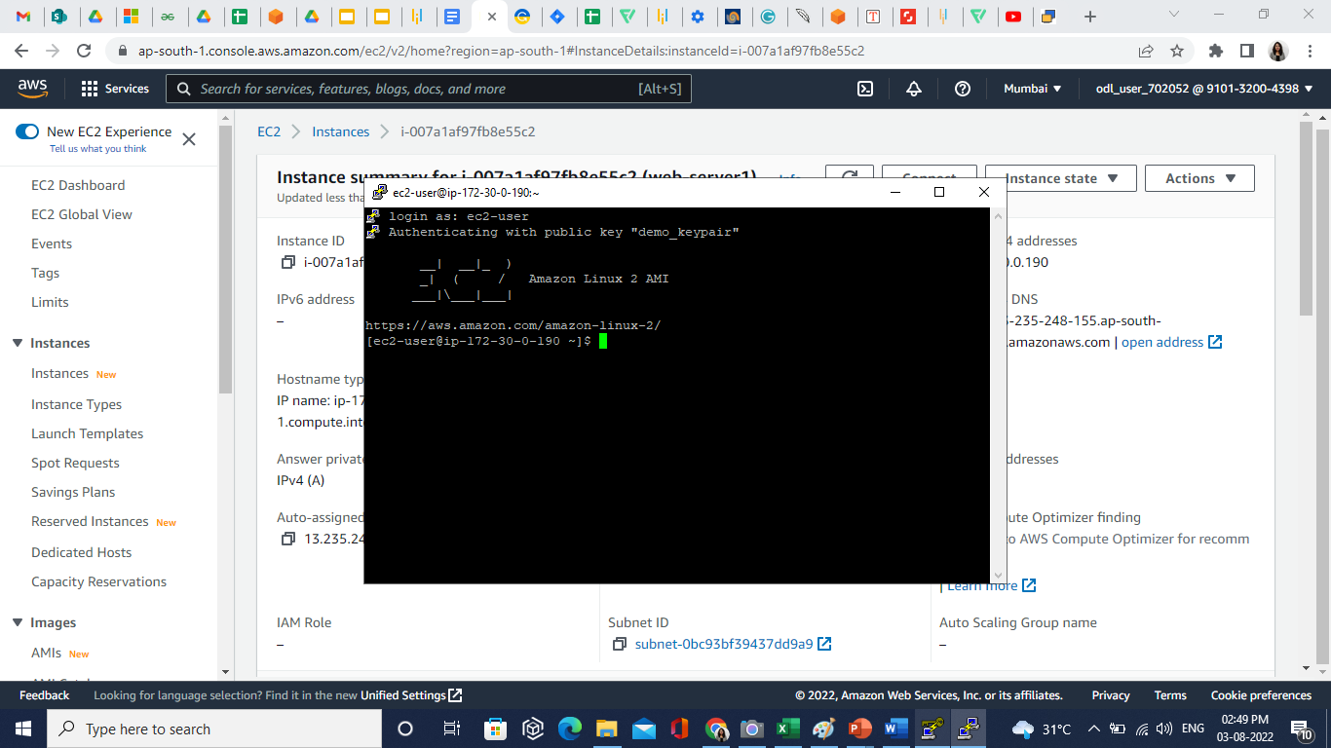

**Step 4: Install an Apache Web Server with PHP**

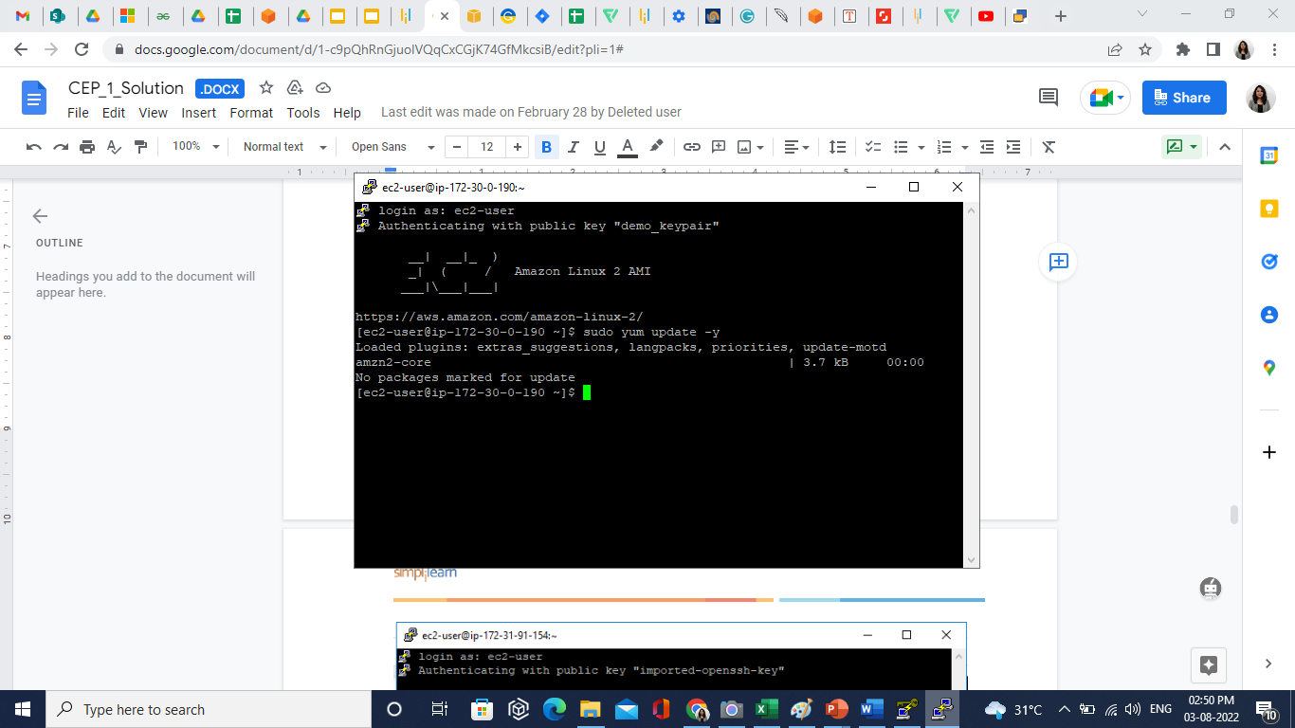

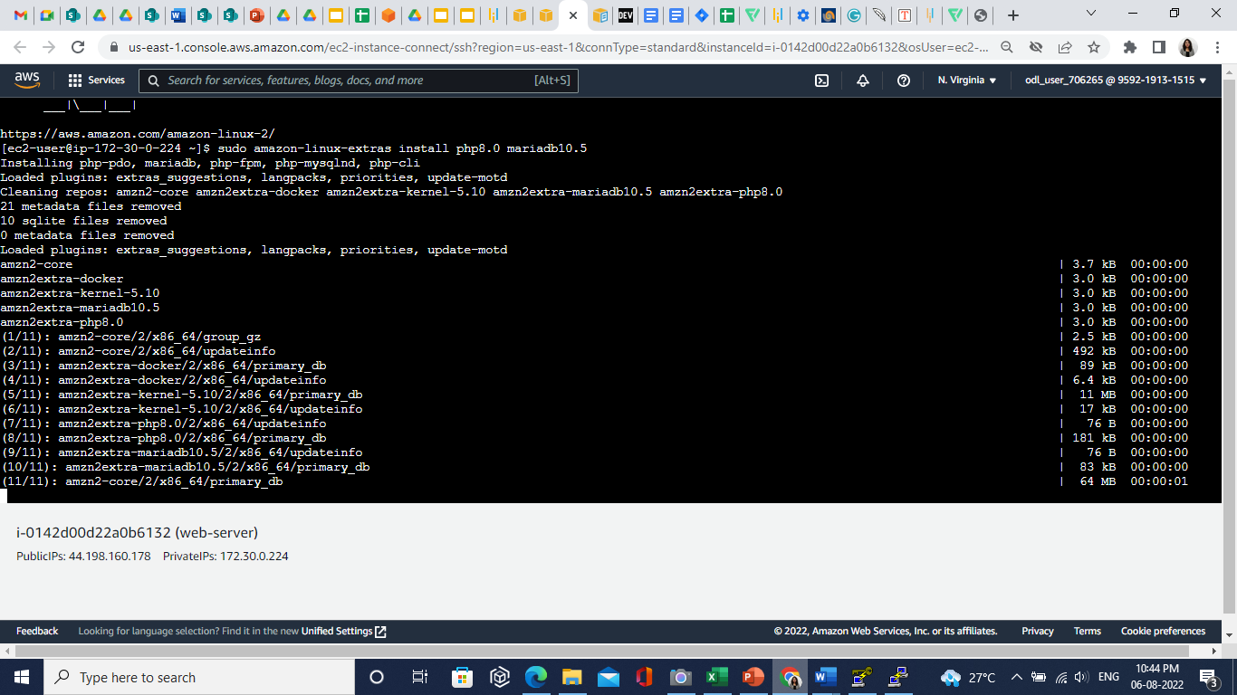

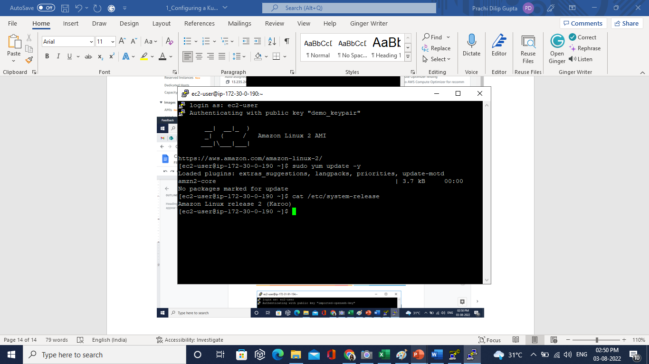

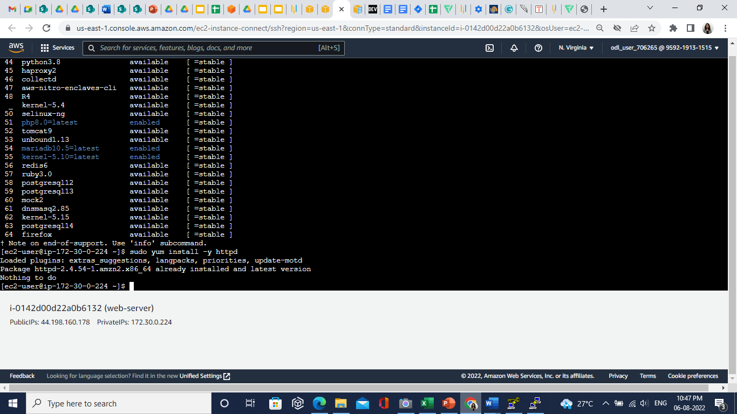

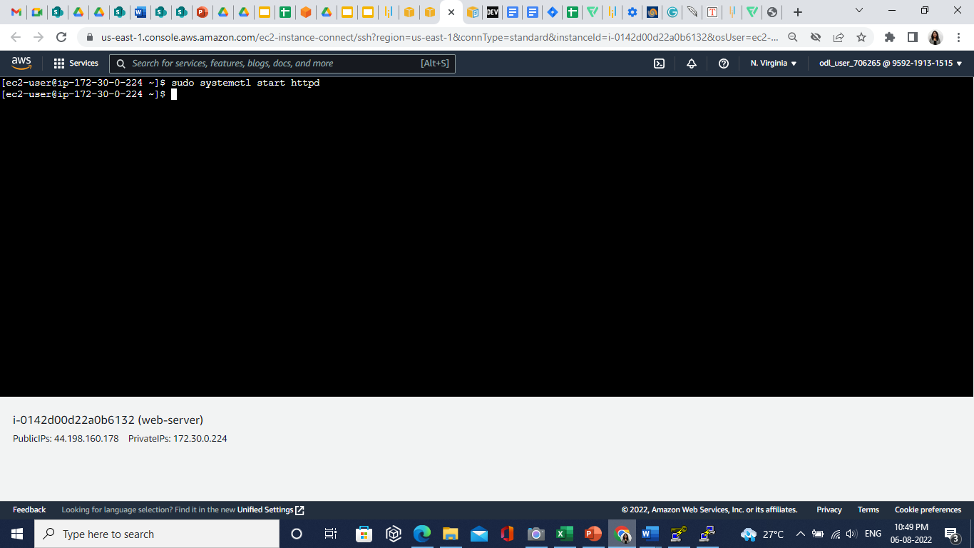

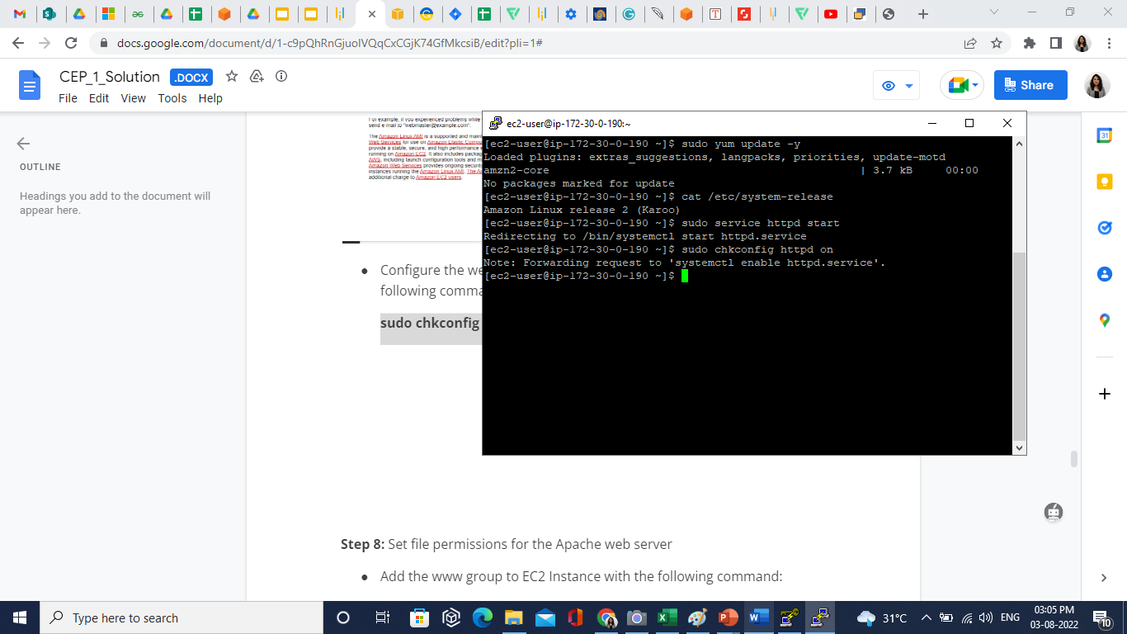

**Step 5: Set File Permissions for the Apache Web Server**

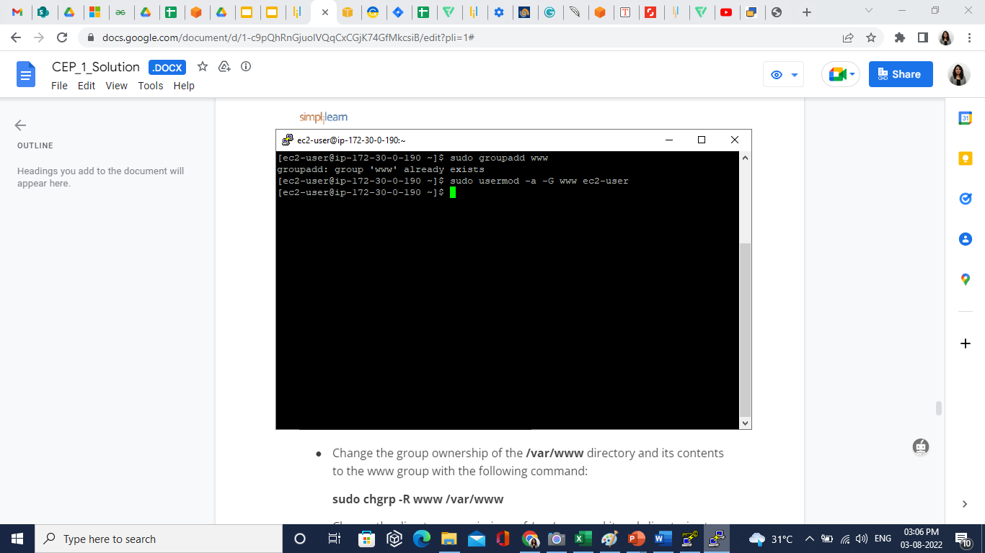

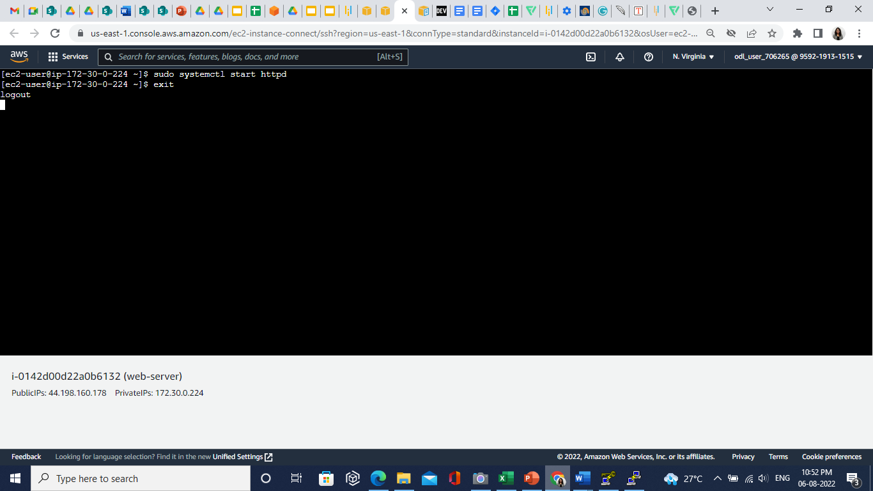

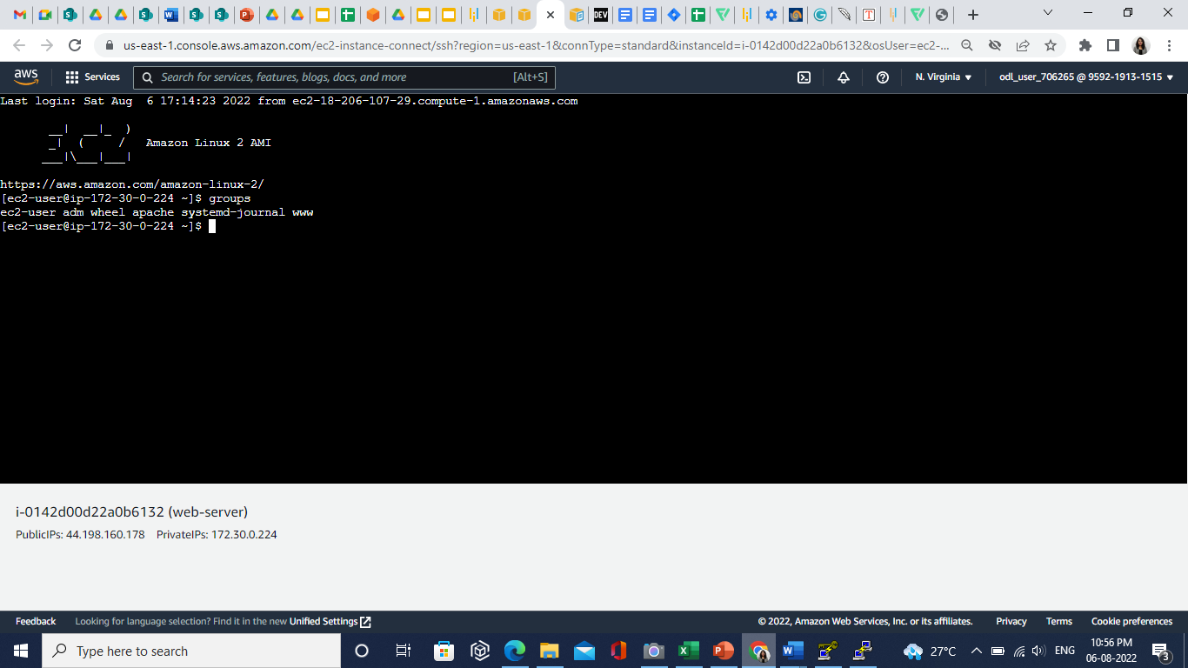

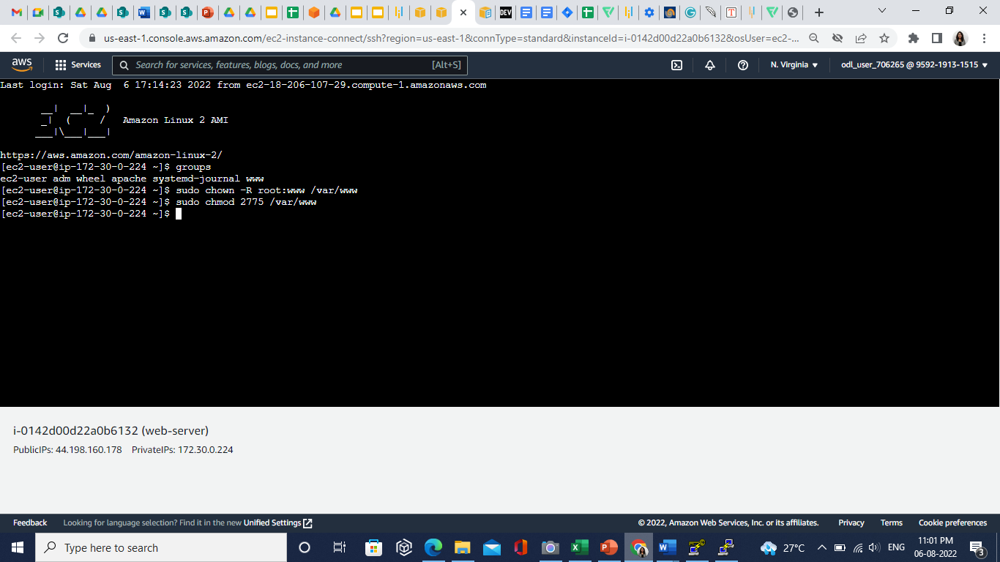

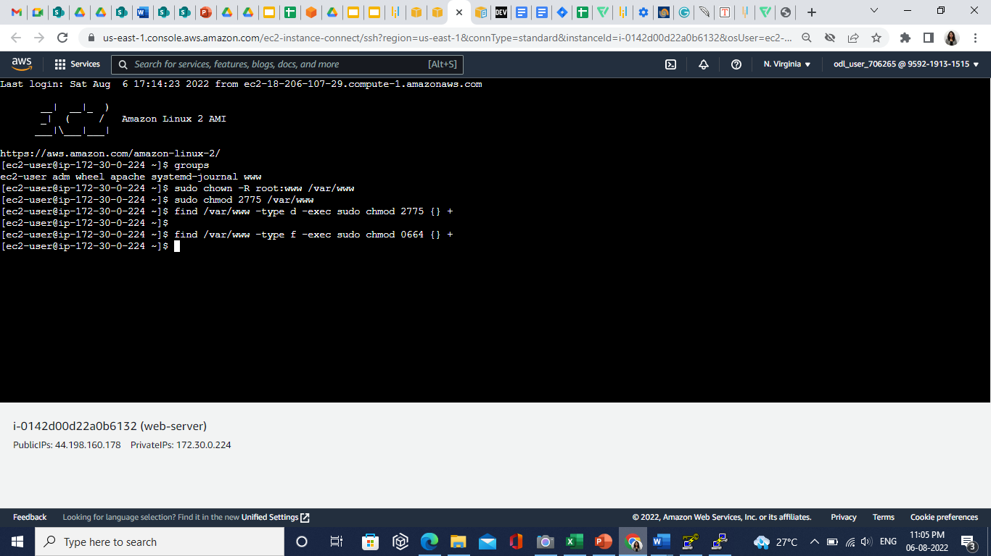

**Step 6: Connect Your Apache Web Server to your Database Instance**

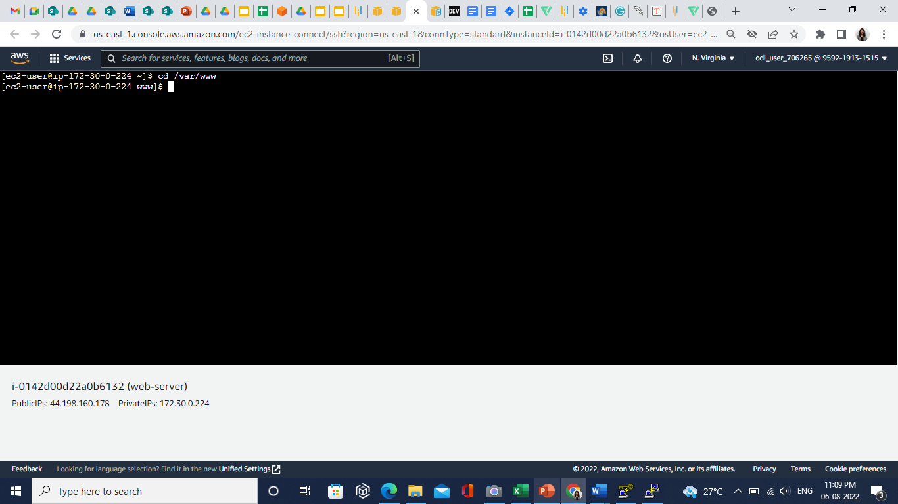

**vim dbinfo.inc**

**<?php**

**define('DB_SERVER', 'db_instance_endpoint');**

**define('DB_USERNAME', 'tutorial_user');**

**define('DB_PASSWORD', 'master password');**

**define('DB_DATABASE', 'sample');**

**?>**

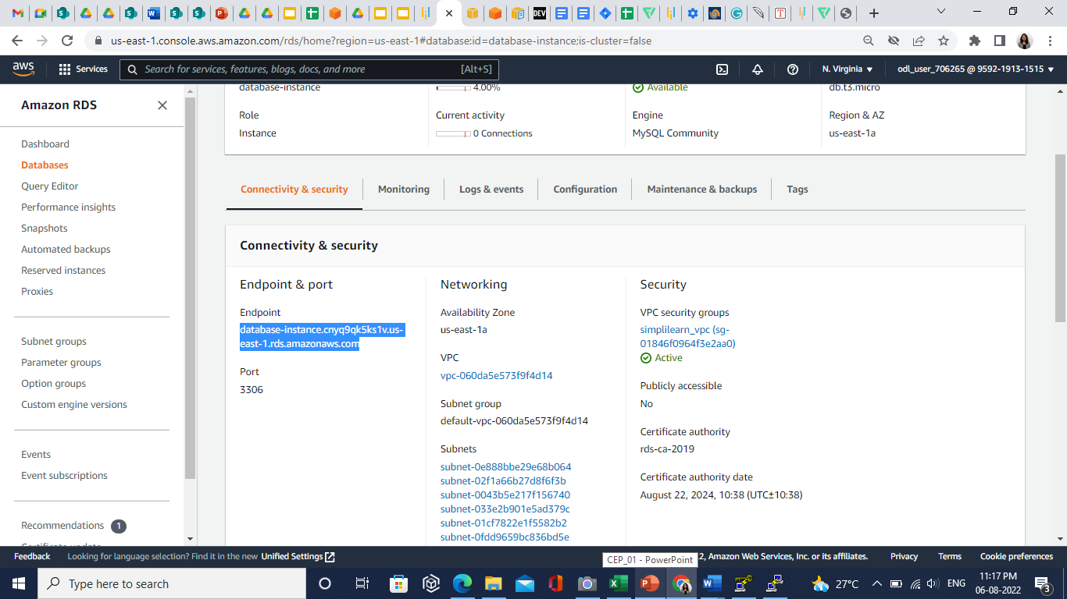

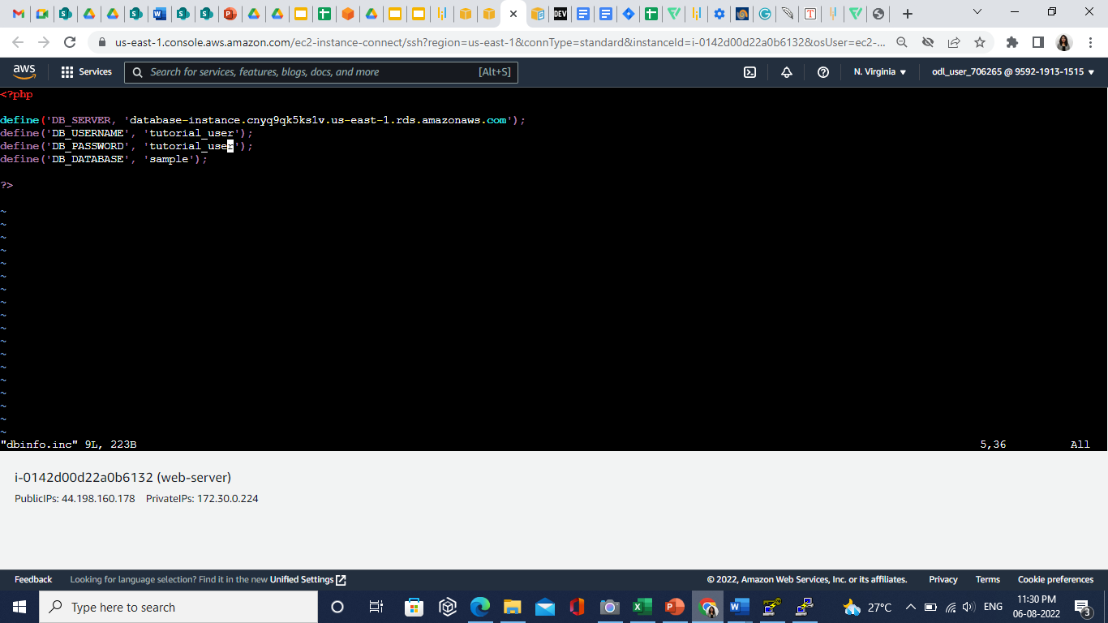

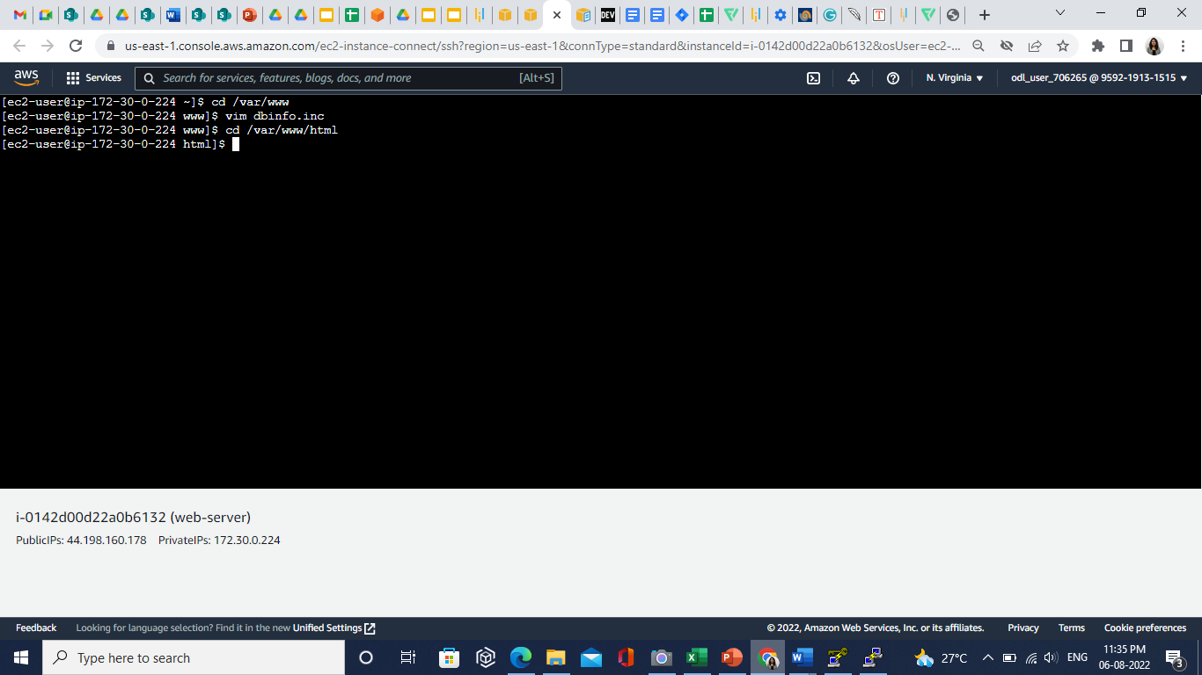

**vim SamplePage.php**

**<?php include "../inc/dbinfo.inc"; ?>**

**<html>**

**<body>**

**<h1>Sample page</h1>**

**<?php**

**/* Connect to MySQL and select the database. */**

**$connection = mysqli_connect(DB_SERVER, DB_USERNAME, DB_PASSWORD);**

**if (mysqli_connect_errno()) echo "Failed to connect to MySQL: " . mysqli_connect_error();**

**$database = mysqli_select_db($connection, DB_DATABASE);**

**/* Ensure that the EMPLOYEES table exists. */**

**VerifyEmployeesTable($connection, DB_DATABASE);**

**/* If input fields are populated, add a row to the EMPLOYEES table. */**

**$employee_name = htmlentities($_POST['NAME']);**

**$employee_address = htmlentities($_POST['ADDRESS']);**

**if (strlen($employee_name) || strlen($employee_address)) {**

**AddEmployee($connection, $employee_name, $employee_address);**

**}**

**?>**

**<!-- Input form -->**

**<form action="<?PHP echo $_SERVER['SCRIPT_NAME'] ?>" method="POST">**

**<table border="0">**

**<tr>**

**<td>NAME</td>**

**<td>ADDRESS</td>**

**</tr>**

**<tr>**

**<td>**

**<input type="text" name="NAME" maxlength="45" size="30" />**

**</td>**

**<td>**

**<input type="text" name="ADDRESS" maxlength="90" size="60" />**

**</td>**

**<td>**

**<input type="submit" value="Add Data" />**

**</td>**

**</tr>**

**</table>**

**</form>**

**<!-- Display table data. -->**

**<table border="1" cellpadding="2" cellspacing="2">**

**<tr>**

**<td>ID</td>**

**<td>NAME</td>**

**<td>ADDRESS</td>**

**</tr>**

**<?php**

**$result = mysqli_query($connection, "SELECT * FROM EMPLOYEES");**

**while($query_data = mysqli_fetch_row($result)) {**

**echo "<tr>";**

**echo "<td>",$query_data[0], "</td>",**

**"<td>",$query_data[1], "</td>",**

**"<td>",$query_data[2], "</td>";**

**echo "</tr>";**

**}**

**?>**

**</table>**

**<!-- Clean up. -->**

**<?php**

**mysqli_free_result($result);**

**mysqli_close($connection);**

**?>**

**</body>**

**</html>**

**<?php**

**/* Add an employee to the table. */**

**function AddEmployee($connection, $name, $address) {**

**$n = mysqli_real_escape_string($connection, $name);**

**$a = mysqli_real_escape_string($connection, $address);**

**$query = "INSERT INTO EMPLOYEES (NAME, ADDRESS) VALUES ('$n', '$a');";**

**if(!mysqli_query($connection, $query)) echo("<p>Error adding employee data.</p>");**

**}**

**/* Check whether the table exists and, if not, create it. */**

**function VerifyEmployeesTable($connection, $dbName) {**

**if(!TableExists("EMPLOYEES", $connection, $dbName))**

**{**

**$query = "CREATE TABLE EMPLOYEES (**

**ID int(11) UNSIGNED AUTO_INCREMENT PRIMARY KEY,**

**NAME VARCHAR(45),**

**ADDRESS VARCHAR(90)**

**)";**

**if(!mysqli_query($connection, $query)) echo("<p>Error creating table.</p>");**

**}**

**}**

**/* Check for the existence of a table. */**

**function TableExists($tableName, $connection, $dbName) {**

**$t = mysqli_real_escape_string($connection, $tableName);**

**$d = mysqli_real_escape_string($connection, $dbName);**

**$checktable = mysqli_query($connection,**

**"SELECT TABLE_NAME FROM information_schema.TABLES WHERE TABLE_NAME = '$t' AND TABLE_SCHEMA = '$d'");**

**if(mysqli_num_rows($checktable) > 0) return true;**

**return false;**

**}**

**?>**

* Press **esc** key, then enter :wq to save the code.
  1. Go back to the EC2 instance, click on the created instance, and copy the **Public IPv4 address**.

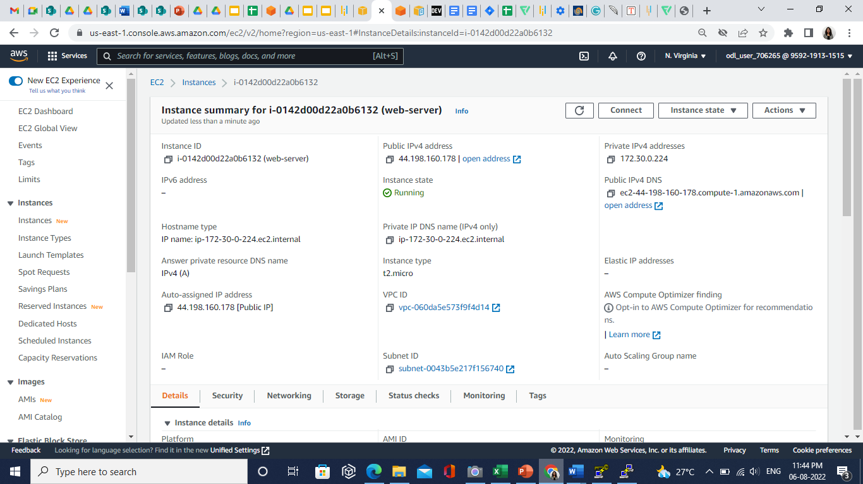

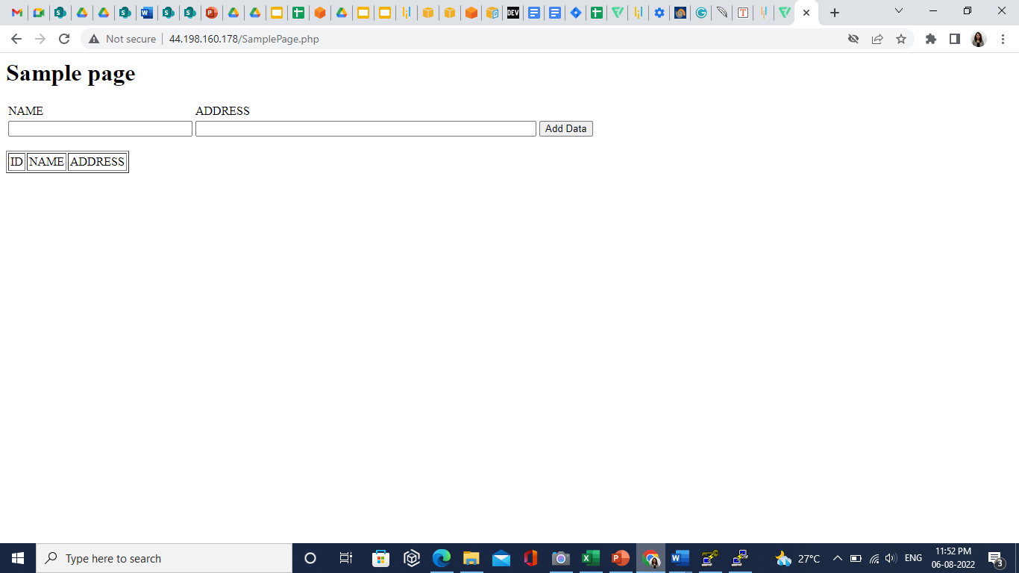

**Step 7: Monitor the Portal Using Route 53**

